Contents
1. Caregiver Mobile App – OVERVIEW 7
1.1. Description 7
1.1.1. User Interface - Menu Options 8
2. Landing Page Tiles 10
3. Dashboard – Visit Dashboard 11
3.1. Description 11
3.2. Instantiation of the Event 11
3.3. User Interface Design 11
3.3.1. Screen Layout 11
3.3.2. Wireframe 12
4. My schedule 13
4.1. Description 13
4.2. Instantiation of the Event 13
4.3. User Interface Design 13
4.3.1. Screen Layout 13
4.3.2. Wireframe 14
4.3.3. Mark Arrival (refer main section) 19
4.3.4. View Summary – make the screen heading as View summary 20
4.4. Screen Behavior 20
4.5. Attributes Description 22
4.6. Messages and Validations 22
4.7. Security and Permissions 23
4.8. Backend API Requirements 23
4.9. Audit Trail 23
4.10. Error Handling and Edge Cases 24
5. Patient Profile – Patient List (Overview) 25
5.1. Description 25
5.2. Instantiation of the Event 25
5.3. User Interface Design 25
5.3.1. Screen Layout 25
5.3.2. Wireframe 25
5.4. Screen Behavior 26
5.5. Attributes Description 27
5.6. Messages and Validations 27
5.7. Security and Permissions 28
5.8. Backend API Requirements 28
5.9. Audit Trail 28
5.10. Error Handling and Edge Cases 28
6. Pending Notes 29
6.1. Description 29
6.2. Instantiation of the Event 29
6.3. User Interface Design 29
6.3.1. Screen Layout 29
6.3.2. Wireframe 29
6.4. Screen Behavior 32
6.5. Attributes Description 32
6.6. Messages and Validations 32
6.7. Security and Permissions 33
6.8. Backend API Requirements 33
6.9. Audit Trail 33
6.10. Error Handling and Edge Cases 33
7. My schedule – Start Visit 34
7.1. Description 34
7.2. Instantiation of the Event 34
7.3. User Interface Design 34
7.4. Screen Behavior 35
7.5. Attributes Description 36
7.6. Messages and Validations 36
7.7. Security and Permissions 37
7.8. Backend API Requirements 37
7.9. Audit Trail 38
7.10. Error Handling and Edge Cases 38
8. My schedule – Mark Arrival 39
8.1. Description 39
8.2. Instantiation of the Event 39
8.3. User Interface Design 39
8.4. Screen Behavior 40
8.5. Attributes Description 41
8.6. Messages and Validations 42
8.7. Security and Permissions 42
8.8. Backend API Requirements 42
8.9. Audit Trail 43
8.10. Error Handling and Edge Cases 43
9. Start Visit – Vitals Entry / Device Sync 46
9.1. Description 46
9.2. Instantiation of the Event 46
9.3. User Interface Design 46
9.4. Screen Behavior 47
9.5. Attributes Description 48
9.6. Messages and Validations 48
9.7. Security and Permissions 48
9.8. Backend API Requirements 49
9.9. Audit Trail 49
9.10. Error Handling and Edge Cases 49
10. Start Visit – Care Plan Notes / Progress Remarks 50
10.1. Description 50
10.2. Instantiation of the Event 50
10.3. User Interface Design 50
10.4. Screen Behavior 51
10.5. Attributes Description 52
10.6. Messages and Validations 53
10.7. Security and Permissions 53
10.8. Backend API Requirements 53
10.9. Audit Trail 54
10.10. Error Handling and Edge Cases 54
11. Start Visit – Escalate to Doctor 55
11.1. Description 55
11.2. Instantiation of the Event 55
11.3. User Interface Design 55
11.4. Screen Behavior 56
11.5. Attributes Description 57
11.6. Messages and Validations 58
11.7. Security and Permissions 58
11.8. Backend API Requirements 58
11.9. Audit Trail 59
11.10. Error Handling and Edge Cases 59
12. Documentation – Image/Document Upload 60
12.1. Description 60
12.2. Instantiation of the Event 60
12.3. User Interface Design 60
12.4. Screen Behavior 61
12.5. Attributes Description 62
12.6. Messages and Validations 62
12.7. Security and Permissions 63
12.8. Backend API Requirements 63
12.9. Audit Trail 64
12.10. Error Handling and Edge Cases 64
13. Communication – Supervisor Chat 66
13.1. Description 66
13.2. Instantiation of the Event 66
13.3. User Interface Design 66
13.4. Screen Behavior 67
13.5. Attributes Description 68
13.6. Messages and Validations 68
13.7. Security and Permissions 69
13.8. Backend API Requirements 69
13.9. Audit Trail 69
13.10. Error Handling and Edge Cases 70
14. Alerts & Messages – Notifications Center 71
14.1. Description 71
14.2. Instantiation of the Event 71
14.3. User Interface Design 71
14.4. Screen Behavior 72
14.5. Attributes Description 73
14.6. Messages and Validations 73
14.7. Security and Permissions 74
14.8. Backend API Requirements 74
14.9. Audit Trail 74
14.10. Error Handling and Edge Cases 74
15. Sync Queue – Sync Status & Retry Screen 76
15.1. Description 76
15.2. Instantiation of the Event 76
15.3. User Interface Design 76
15.4. Screen Behavior 77
15.5. Attributes Description 78
15.6. Messages and Validations 78
15.7. Security and Permissions 79
15.8. Backend API Requirements 79
15.9. Audit Trail 79
15.10. Error Handling and Edge Cases 80
16. Settings – Language & Notifications 81
16.1. Description 81
16.2. Instantiation of the Event 81
16.3. User Interface Design 81
16.4. Screen Behavior 82
16.5. Attributes Description 82
16.6. Messages and Validations 82
16.7. Security and Permissions 82
16.8. Backend API Requirements 82
16.9. Audit Trail 83
16.10. Error Handling and Edge Cases 83
17. Settings – Profile & Contact Info 84
17.1. Description 84
17.2. Instantiation of the Event 84
17.3. User Interface Design 84
17.4. Screen Behavior 85
17.5. Attributes Description 85
17.6. Messages and Validations 85
17.7. Security and Permissions 86
17.8. Backend API Requirements 86
17.9. Audit Trail 86
17.10. Error Handling and Edge Cases 86
18. Settings – Security Settings 87
18.1. Description 87
18.2. Instantiation of the Event 87
18.3. User Interface Design 87
18.4. Screen Behavior 88
18.5. Attributes Description 88
18.6. Messages and Validations 88
18.7. Security and Permissions 89
18.8. Backend API Requirements 89
18.9. Audit Trail 89
18.10. Error Handling and Edge Cases 89
19. Settings – App Info & Help 90
19.1. Description 90
19.2. Instantiation of the Event 90
19.3. User Interface Design 90
19.4. Screen Behavior 91
19.5. Attributes Description 91
19.6. Messages and Validations 91
19.7. Security and Permissions 92
19.8. Backend API Requirements 92
19.9. Audit Trail 92
19.10. Error Handling and Edge Cases 92
20. Settings – Caregiver Preferences 93
20.1. Description 93
20.2. Instantiation of the Event 93
20.3. User Interface Design 93
20.4. Screen Behavior 94
20.5. Attributes Description 94
20.6. Messages and Validations 94
20.7. Security and Permissions 94
20.8. Backend API Requirements 94
20.9. Audit Trail 95
20.10. Error Handling and Edge Cases 95
21. APPENDICES 97
21.1. Data Model 97
21.1.1. Core Collections Design 97
21.1.2. Data Relationships (Reference Model) 98
21.1.3. Recommended Indexing 98
21.1.4. Permissions Layer (Suggested Roles) 98
21.2. ERD 98
21.2.1. Diagram 98
21.2.2. Highlights 99
21.3. Sync Visit Vs Offline Sync Status 99
21.3.1. Sync Visit (Visit-Level Sync Screen) 99
21.3.2. Offline Sync Status (Global Sync Queue) 100
21.3.3. Key Difference: 100

Caregiver Mobile App – OVERVIEW

Description
The Caregiver Mobile App is a field-ready, NHRA-compliant digital assistant designed specifically for home healthcare professionals, including nurses, physiotherapists, wound care specialists, and visiting doctors. It enables caregivers to seamlessly manage their daily visits, record clinical activities, and engage with patients and supervisors—all from a secure mobile interface.
Through features like My schedule, vitals capture (including IoT device integration), emergency escalation, real-time messaging, and offline functionality, the app empowers caregivers to deliver high-quality, consistent, and accountable care in patients’ homes. With GPS check-in/check-out and task verification, it also ensures operational transparency and audit-readiness for healthcare providers operating in Bahrain's regulated home care environment.

Key Capabilities Across the Care Continuum:
Functional Module | Purpose
Dashboard & Visit Management | View scheduled visits, navigate to patient homes, and track task completion in a calendar-friendly layout.
Patient Overview | Access comprehensive patient profiles, including medical history, allergies, CPR number, and chronic conditions.
My schedule | Complete all care tasks with an intuitive checklist – from wound dressing to pain score entry – while capturing real-time updates.
Vitals Entry & Device Sync | Record vitals manually or sync with Bluetooth-enabled IoT devices for automated health data capture.
Clinical Notes | Add progress updates, observations, and attach clinical media as part of structured note entry with timestamped audit trails.
Emergency Escalation | Instantly alert supervisors or doctors during critical events through an integrated red-alert button with call/message capability.
Documentation Upload | Attach prescriptions, wound photos, and other medical forms for centralized storage and clinical visibility.
GPS Check-In/Out (EVV) | Mark attendance using GPS, NFC, or OTP for full Electronic Visit Verification (EVV) compliance per NHRA or CMS regulations.
Secure Communication | Engage in HIPAA-compliant real-time chat with supervisors or doctors for timely clarifications and support.
Notifications Center | View reminders, task escalations, policy updates, and shift alerts in one streamlined notification hub.
Offline Sync & Retry | Log actions without internet, then sync securely when online with full transparency on pending and failed items.

User Interface - Menu Options
Landing page will display - tile based menu options.

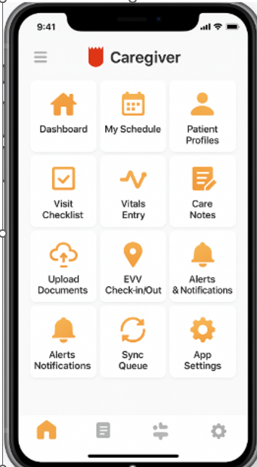

Clickin on the following tiles will display:

Dashboard – Visit Dashboard
My schedule – all the care giver’s visits that day
Patient profile – list all the patient that has been associated with the logged in care – giver.
Sync Queue – syncs up the offline data
Chat with supervisor – will let the caregiver to communicate with supervisor
Alert Notifcation – displays all the notifications sent to the caregiver by the Hospital system
Settings – displays both general app settings and settings related to homecare.

Landing Page Tiles
- Dashboard
- My schedule
- Patient Profile – List and overview
- Pending Notes
- Sync Queue
- Chat with supervisor
- Alert Notifcation
- Settings

Dashboard – Visit Dashboard

Description
The Landing Dashboard is the home screen that appears when a caregiver logs into the mobile app. It provides a quick overview of daily assignments, the next upcoming visit, status summaries, and access to key actions such as starting a visit, syncing data, and checking pending notes. It acts as the caregiver’s control center for daily field operations.

Instantiation of the Event
- Trigger: User logs into the caregiver mobile app successfully
- Entry Points:
  - App launch (auto-login if token exists)
  - Manual login via credentials
  - Return from background (if app remains active)
- Pre-conditions:
  - User must be authenticated
  - User role is set as Caregiver
  - At least one assigned visit for the current day
- Post-conditions:
  - Today’s visit summary is visible
  - Next visit details displayed
  - Visit actions (Start, Mark Arrival) are available
  - Quick links are enabled for extended functions

User Interface Design

Screen Layout
UI Component | Description
Top Bar (App Title) | App branding ("HealthNurse – Caregiver App") + hamburger menu + alerts icon
Greeting Section | Welcome message with caregiver name + today’s date
Daily Summary Panel | Shows total visits, pending, in-progress, completed counts for the day
Next Visit Card | Highlights next upcoming visit: time, location, patient name, tasks, start button
Visit List Section | Lists all scheduled visits for the day with actions (Start, Mark Arrival, View Summary)
Quick Actions Toolbar | Buttons for: View Schedule, Pending Notes, Visit Summary, Sync Offline Data

Wireframe

Dashboard
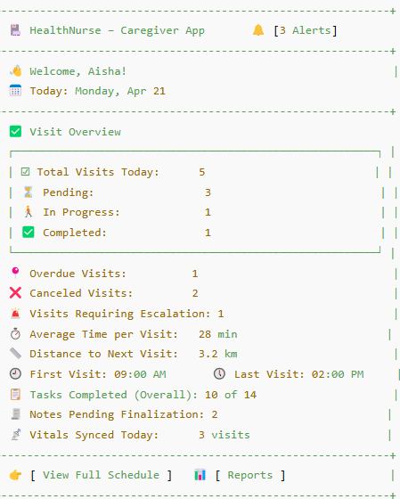
REMOVE FULL SCHEDULE AND REPORTS

My schedule

Description
This screen displays the caregiver’s full daily or weekly visit schedule. It allows filtering visits by patient name or location, switching between day/week views, and provides quick access to start visits, mark arrivals, or view visit summaries. It ensures caregivers have a clear and structured view of their tasks for the day or week.

Instantiation of the Event
- Trigger: Tap on the My Schedule tile from the landing page/dashboard.
- Entry Point: Caregiver Home Screen → My Schedule
- Pre-conditions:
  - Caregiver is logged in.
  - Visit assignments exist for the selected day or week.
- Post-conditions:
  - Caregiver can initiate a visit, mark arrival, or review completed visits.

User Interface Design

Screen Layout
UI Component | Description
🔙 Back Button | Returns to the caregiver home/dashboard.
📅 Full Visit Schedule | Text label indicating the current screen.
🔍 Search Field | Search box to filter visits by patient name or location.
🗓️ Filter by Date | Date picker to view visits scheduled for a selected day.
🔄 Toggle View | Option to switch between Day View and Week View.
🕘 Time Slot (e.g., 09:00 AM – 09:45 AM) | Shows time window of visit.
👤 Patient Name | Name of the patient assigned for the visit.
📍 Location | Visit type and address (e.g., Home Visit – Isa Town).
📋 Tasks | Care tasks scheduled (e.g., Medication, BP Check, etc.).
⭐ Status | Status of visit – Pending, Not Started, Completed.
⏱️ Start Visit / Mark Arrival / View Summary | Action buttons shown contextually based on visit status.

Wireframe

My Schedule – Visit List
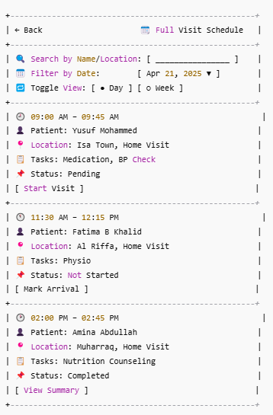

Start Visit (refer main section)
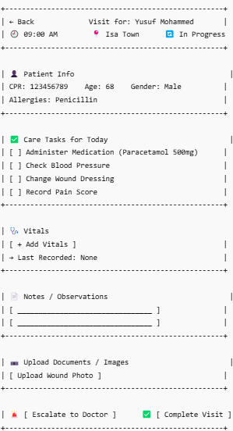
NOTE to chiranth: REMOVE THE WORD Notes from Notes/Observations

Escalate to Doctor
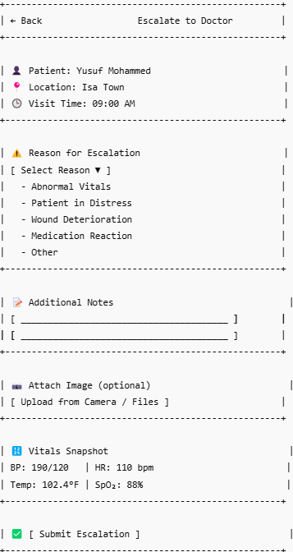
NOTE: Change the Additional Notes caption to - Comments

Complete Visit – Visit Completion summary
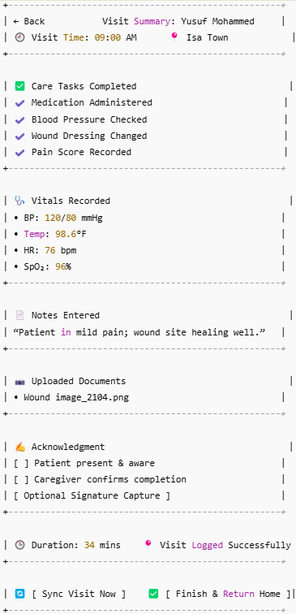

Sync Visit Now

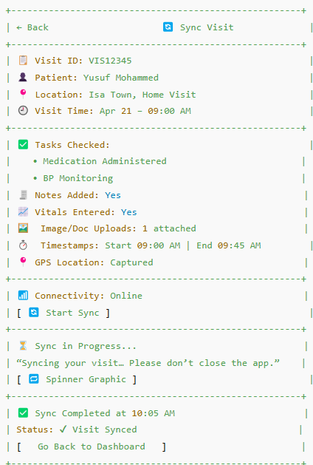

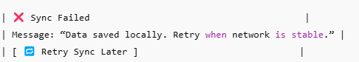

- Start Sync Process
  - App gathers all visit-related data:
    - Checked tasks
    - Vitals entered
    - Notes
    - Uploaded images/documents
    - Timestamps (start, end)
    - GPS coordinates (if enabled)
- Connectivity Check
  - App verifies if internet is currently available:
    - If yes → proceeds to sync
    - If no → shows: “No internet connection. Retry later.”
- Sync Execution
  - Data is sent securely to backend via API (/api/visit/sync)
  - Includes metadata to update audit trails
- Progress Indicator
  - A spinner or loader is shown with the message:
“Syncing your visit… Please don’t close the app.”
- Confirmation Message
  - On success:
“Visit successfully synced with server at [time]”
  - On failure:
“Sync failed. Data saved locally. Retry when network is stable.”
- UI State Update
  - “Sync Visit Now” button is removed or disabled
  - Status shown as: Visit Synced or ✅ icon displayed

Mark Arrival (refer main section)
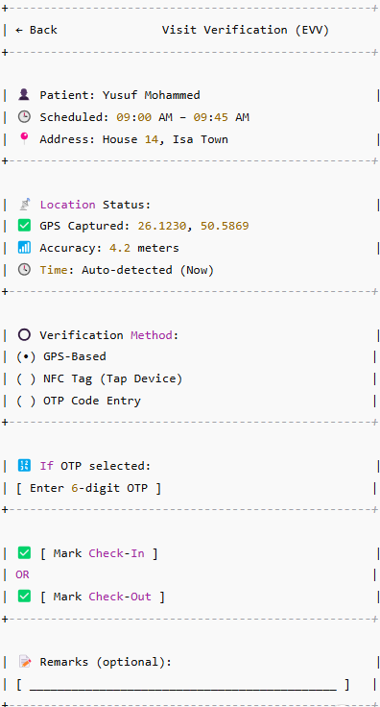

View Summary – make the screen heading as View summary
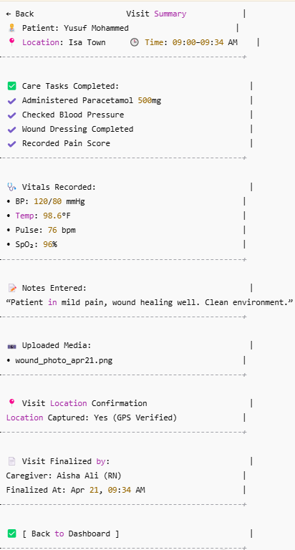

Screen Behavior
Each UI Field & Behavior:
- App Title / Logo (HealthNurse):
  - Static branding on top, links to About screen if tapped (optional)
- Alert Icon (🔔):
  - Shows badge with number of pending alerts (e.g., critical vitals, escalation)
  - Tapping opens Alerts & Notifications screen
- Welcome Message (e.g., Welcome, Aisha!):
  - Personalized using logged-in user’s name
- Date (e.g., Monday, Apr 21):
  - Always current day; date selector is not enabled here
- Visit Summary Panel (Total, Pending, etc.):
  - Auto-calculated based on caregiver’s schedule
  - "In Progress" appears if caregiver has started a visit but hasn’t completed it
- Next Visit Card:
  - Dynamically shows the earliest unstarted visit
  - “Start Visit” button is enabled only 30 minutes before scheduled time
- Visit List:
  - Scrollable section showing all today’s visits
  - Statuses: Pending / Not Started / In Progress / Completed
  - Actions vary by status (e.g., “Mark Arrival” if within 15 mins of start time)
- Quick Actions:
  - Shortcut buttons open respective modules
  - “Sync” is only shown if offline entries are pending

Screen Name | Screen Behavior
Landing Dashboard | Displays daily visit overview, next visit, and access to actions like Start Visit, Mark Arrival, etc.
Mark Arrival | Captures GPS location, arrival timestamp, optional note/photo.
My schedule | Displays care tasks as checkboxes, allows vitals entry, notes, uploads, and escalation. Finalizes visit.
Vitals Entry | Records vital signs manually or via device. Saves to visit log with timestamp and measurement source.
Escalate to Doctor | Allows caregiver to raise alert to doctor with reason, notes, vitals, optional media. Triggers notification.
Visit Completion Summary | Displays all logged data in read-only form, including tasks, vitals, notes, and visit duration.
View Summary | Caregiver can review previously completed visits in a detailed, read-only format.
Pending Notes | Lists visits that are missing required documentation. Each item links to Add Notes screen.
Add Notes Now | Enables caregiver to input clinical notes, pain score, activity, and save to finalize visit.
Visit Finalization Confirmation | Confirms successful visit completion and data sync. Displays duration, caregiver name, timestamp.
Sync Offline Data | Lists unsynced visits. Allows retrying individual or bulk sync with network check and feedback.

Attributes Description
Field Name | Description | Type | Validation
username | Logged-in caregiver's name | Text | Must not be null
current_date | System date | Date | Must match system date; cannot be modified
visit_total_count | Count of total visits assigned today | Integer | Auto-calculated from schedule
visit_pending_count | Count of visits not yet started | Integer | Must be ≥ 0
visit_inprogress_count | Count of ongoing visits | Integer | Cannot exceed 1 at a time per caregiver
visit_completed_count | Completed visits count | Integer | Auto-incremented upon completion
next_visit_time | Scheduled time for next visit | Time (HH:MM) | Must be ≥ current time
next_visit_patient_name | Name of patient for next visit | Text | Must be associated with a valid patient ID
visit_tasks[] | List of tasks for each visit | Text Array | Each task must be linked to care plan
visit_status | Current status of a visit | Enum | Must be one of: Pending, In Progress, Completed

Messages and Validations
Scenario | Message / Validation
No visits assigned today | “No visits scheduled for today.”
Attempting to start visit too early | “You can start this visit only within 30 minutes of scheduled time.”
Trying to start a second visit while one is ongoing | “You must complete your current visit before starting a new one.”
Sync failures due to offline mode | “Some data is pending sync. Please retry when online.”
Missing patient tasks | “No tasks assigned for this visit. Contact your supervisor.”

Security and Permissions
Action | Required Permission | Roles
View dashboard | caregiver.dashboard.view | Caregiver
Start visit | caregiver.visit.start | Caregiver
Mark visit arrival | caregiver.visit.mark_arrival | Caregiver
View patient details | caregiver.patient.view_basic | Caregiver, Supervisor
Access visit summary | caregiver.visit.summary.read | Caregiver, Supervisor
View sync queue | caregiver.sync.status.read | Caregiver
Access alerts & notifications | caregiver.alerts.read | Caregiver, Supervisor

Backend API Requirements
Endpoint | Method | Description | Request Payload | Response
/api/caregiver/dashboard | GET | Fetch today's summary and visit list | Auth token | JSON: visit counts, next visit, list
/api/caregiver/visit/start | POST | Mark a visit as started | visit_id, caregiver_id | JSON: success/failure
/api/caregiver/visit/arrival | POST | Mark arrival at visit location | visit_id, timestamp, gps_coords | JSON: confirmation
/api/caregiver/alerts | GET | Get alert/notification list | caregiver_id | JSON: alerts array
/api/caregiver/sync/status | GET | Check for unsynced items | caregiver_id | JSON: pending items count, details
/api/caregiver/visit/summary | GET | Retrieve past visit summaries | visit_id | JSON: summary data

Audit Trail
Event | Captured Fields
Caregiver login | username, device_id, login_time, location
Dashboard loaded | caregiver_id, timestamp, visit_count, next_visit_id
Visit started | caregiver_id, visit_id, start_time, gps_coords
Visit arrival marked | visit_id, arrival_time, location, device_id
Alert viewed | alert_id, caregiver_id, viewed_time

Error Handling and Edge Cases
Scenario | System Behaviour
API call fails due to no internet | Show offline sync banner, store action locally
Attempt to start visit outside allowed window | Show message: “Too early to start visit”
Visit list API returns empty | Show “No visits scheduled for today” placeholder
User logs in but has no assigned visits | Dashboard loads with empty state and support contact info
GPS not enabled when marking arrival | Prompt to enable GPS + block visit start until enabled
Unexpected data sync error | Retry option shown + background auto-retry queued

Patient Profile – Patient List (Overview)

Description
The Patient Quick Profile View screen provides caregivers with a consolidated snapshot of the patient’s key demographic and clinical information. It supports informed care delivery by giving visibility into CPR ID, allergies, chronic conditions, medications, and uploaded reports.

Instantiation of the Event
- Trigger: Caregiver taps on a patient’s name or a “View Patient Info” option
- Entry Points:
  - From the Visit Card in the Landing Dashboard
  - From the “Patient Profiles” menu in the left navigation drawer
- Pre-conditions:
  - Caregiver must be logged in
  - Patient must be assigned to the caregiver
- Post-conditions:
  - Patient’s information is displayed in read-only mode
  - Caregiver can return to the dashboard or proceed to care delivery

User Interface Design

Screen Layout
UI Component | Description
Header (← Back, Title) | Allows navigation back to previous screen, shows “Patient Overview” title
Patient Info Section | Displays patient name, CPR ID, age, gender, address
Allergies Section | Lists known allergies, if any
Chronic Conditions Section | Shows chronic medical conditions (e.g., diabetes, hypertension)
Medications Section | Displays ongoing medications with dosage and frequency
Mental Health / Cognitive | Notes cognitive status or behavioral observations (if available)
Uploaded Documents Section | Allows viewing clinical reports, previous assessments, etc.
Back to Visit Button | Returns caregiver to visit screen or dashboard

Wireframe

Patients list – name CPR Age Gender

Patient Overview
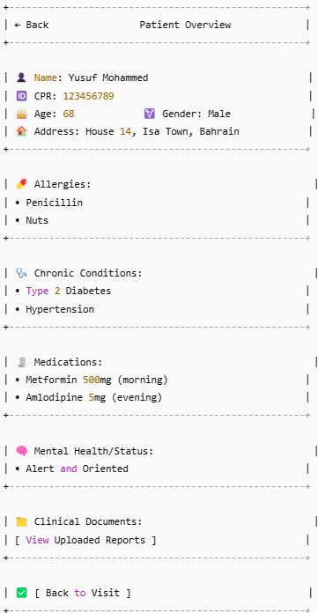

Screen Behavior
- Patient Name
  - Display-only; pulled from patient master record
  - Cannot be edited by caregiver
- CPR ID
  - Read-only unique identifier for the patient
  - Used for SEHATI/NHRA data sync
- Age & Gender
  - Auto-calculated from DOB; gender comes from master profile
  - No edit allowed; incorrect values require admin correction
- Address
  - View-only for location awareness
  - Useful for validating home visits and EVV
- Allergies
  - Display list of known allergies
  - Cannot be modified by caregiver; flag if absent in elderly patients
- Chronic Conditions
  - Pulled from patient history/care plan
  - Helps caregiver adjust procedures (e.g., extra BP checks for hypertensive patients)
- Medications
  - For caregiver reference only; source = doctor's prescription or EMR
  - Medication timing/frequency shown
- Mental/Cognitive Status
  - Helpful for physiotherapists, nurses, geriatric caregivers
  - Might be blank if no mental health history
- Clinical Documents
  - Link to preview/download/view documents (PDF, images)
  - May include consent forms, prescriptions, care plans

Attributes Description
Field Name | Description | Type | Validation
patient_name | Full legal name of patient | Text | Required; read-only
cpr_id | Bahrain CPR ID (unique identifier) | Text | Must be 9 digits; read-only
age | Age (auto-calculated from DOB) | Integer | Calculated; must be ≥ 0
gender | Gender | Text (M/F/Other) | Must match EMR record
address | Registered home address | Text | Required if assigned to home care
allergies[] | List of known allergies | Text Array | Optional, but should be reviewed by caregiver
chronic_conditions[] | Patient’s chronic diagnoses | Text Array | Optional; shown if available in clinical data
medications[] | Current medication regimen | Text Array | Optional; read-only
mental_status | Cognitive or mental health notes | Text | Optional; relevant for specific care plans
documents[] | Links to clinical uploads | File Array | Optional; access-controlled

Messages and Validations
Scenario | Message / Validation
CPR ID missing or invalid | “CPR ID is not available or invalid. Contact Admin.”
No allergies or conditions listed | “No known allergies or chronic conditions recorded.”
Documents section empty | “No uploaded documents available for this patient.”
Attempt to edit patient profile | "This information is read-only. Please contact admin."

Security and Permissions
Action | Required Permission | Roles
View patient profile | patient.profile.view | Caregiver
Access uploaded documents | patient.documents.view | Caregiver, Nurse
View medications/allergies | patient.clinicaldata.view | Caregiver

Backend API Requirements
Endpoint | Method | Description | Request Payload | Response
/api/patient/profile/:patient_id | GET | Fetch patient demographics, allergies, history | Auth token, patient ID | JSON: patient data object
/api/patient/documents/:patient_id | GET | Get list of clinical documents | Auth token, patient ID | JSON: file links, names, metadata

Audit Trail
Event | Captured Fields
Patient profile viewed | caregiver_id, patient_id, timestamp, access_source
Document accessed | document_id, caregiver_id, patient_id, viewed_at

Error Handling and Edge Cases
Scenario | System Behaviour
Patient profile not found | Show error: “Patient profile not available. Please contact admin.”
API failure (network/server issue) | Show offline placeholder: “Unable to load data. Try again later.”
Unauthorized access | Show: “You do not have permission to view this patient’s information.”
Document load failed | Show: “File could not be loaded. Retry or contact support.”

Pending Notes

Description
The Pending Notes module enables caregivers to view and complete clinical documentation for visits that have been marked as completed but still have missing notes such as clinical observations, pain scores, or progress summaries. It ensures that no visit is finalized without mandatory documentation, improving clinical compliance and visit audit readiness.

Instantiation of the Event
- Trigger: Caregiver clicks on the Pending Notes tile on the dashboard.
- Entry Points: Caregiver app → Home screen → Pending Notes tile
- Pre-conditions:
  - Visit must be marked as “Completed” without one or more required documentation fields.
  - Caregiver is logged in and assigned to those visits.
- Post-conditions:
  - Notes are saved and synced.
  - Visit is considered finalized and removed from the pending notes list.

User Interface Design

Screen Layout
UI Component | Description
Pending Visit Cards | Lists visits with missing documentation (patient name, location, visit time, missing fields).
Add Notes Now Button | Launches the note entry screen for that visit.
Completed Visit Section | Lists visits that have already been finalized with all notes.
Finalization Notice | Reminder at the bottom to complete all notes to finalize visits.
Back to Dashboard Button | Returns the caregiver to the dashboard/home screen.

Wireframe

Pending Visit Notes
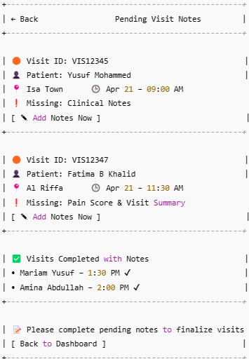

Add Notes Now
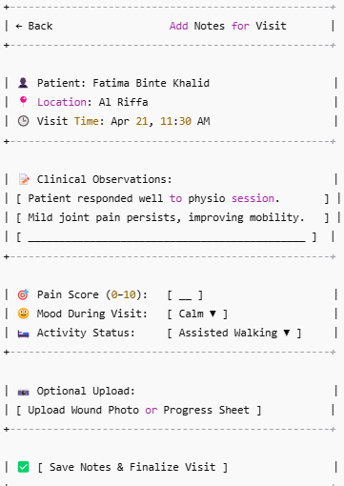

Save notes and finalize visit
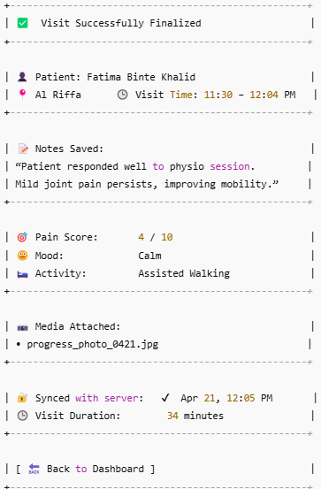

Screen Behavior
Landing Screen
- Caregiver clicks on Pending Notes tile

Pending Visit Notes Screen
- List of all visits where clinical documentation is pending
- For each: Show Visit ID, patient name, time, tasks missing (e.g., clinical notes, pain score)
- Buttons: ➕ Add Notes Now

Add Notes for Visit
- Fill:
  - Clinical Observations (text)
  - Pain Score (0–10)
  - Mood (dropdown)
  - Activity Status (dropdown)
  - Optional Upload (progress photo, sheet)
- Action: Save Notes & Finalize Visit

Visit Finalized Screen
- Shows saved notes
- Sync status, visit duration, attachments
- Confirmation: Visit Successfully Finalized

Attributes Description
Field Name | Description | Type | Validation
Visit ID | Unique identifier for each visit | String | Required, system-generated
Patient Name | Name of the patient | String | Required
Visit Time | Scheduled time of visit | Datetime | Required
Missing Fields | List of note fields not yet entered | List | Must not be empty
Add Notes Button | CTA to enter the missing notes | Button | Enabled only if visit is not finalized

Messages and Validations
Scenario | Message/Validation
No pending notes exist | “All visit notes have been completed.”
Required fields missing on Add Notes page | “Please complete all required note fields.”
Attempt to finalize without notes | “Cannot finalize visit without all notes saved.”

Security and Permissions
Action | Required Permission | Roles
View pending notes | View Visit Notes | Caregiver
Add/Edit notes | Edit Visit Documentation | Caregiver
Finalize visit | Finalize Visit Entry | Caregiver

Backend API Requirements
Endpoint | Method | Description | Request Payload | Response
/api/visits/pending-notes | GET | Fetch all pending visits for caregiver | { caregiver_id: "CG123" } | List of visit objects
/api/visit/{id}/notes | POST | Save clinical notes for visit | { notes, pain_score, mood, media } | { status: "success" }
/api/visit/{id}/finalize | POST | Finalize visit after notes completion | { visit_id } | { status: "finalized" }

Audit Trail
Event | Captured Fields
Notes Entry Started | Visit ID, Caregiver ID, Timestamp
Notes Saved | All fields entered, Timestamp
Visit Finalized | Visit ID, Finalization Timestamp, User ID

Error Handling and Edge Cases
Scenario | System Behaviour
Visit already finalized by another session | Show: “Visit already finalized. No changes allowed.”
API failure during save | Show toast: “Failed to save notes. Please retry.”
Media upload fails | Partial save with retry mechanism for media
Offline mode | Save locally; sync retry will be handled via Sync Queue

My schedule – Start Visit

Description
The Visit Checklist is the core care delivery screen that caregivers use during a home visit. It allows them to mark completion of assigned tasks, record vitals, input clinical notes, escalate concerns, upload relevant documents or images, and finalize the visit.

Instantiation of the Event
- Trigger: Caregiver taps Start Visit or Confirm Arrival from the dashboard
- Entry Points:
  - From Mark Arrival > Confirm Arrival & Start Visit
- Pre-conditions:
  - Visit must be assigned and scheduled for the current caregiver
  - Visit status = Not Started or In Progress
  - Care plan tasks must be linked to the visit
- Post-conditions:
  - Task completion is saved to visit log
  - Vitals and notes are stored
  - Visit can be escalated or marked complete
  - System prepares visit data for sync or billing

User Interface Design

Screen Layout
UI Component | Description
Header (← Back, Title) | Displays title “Visit Checklist” with back navigation to dashboard
Patient Info Banner | Shows patient name, visit time, and location
Task Checklist | Interactive list of tasks assigned via care plan (checkbox-based)
Vitals Summary | Displays last entered vitals or “None” + button to add new vitals
Clinical Notes | Free text field for caregiver observations and additional input
Upload Media Section | Optional button to attach images (e.g., wound photos, progress charts)
Escalate Button | Allows caregiver to report clinical emergencies to supervisor/doctor
Complete Visit Button | Finalizes the visit; enabled only after required elements are completed

Wireframe change the heading to Start Visit
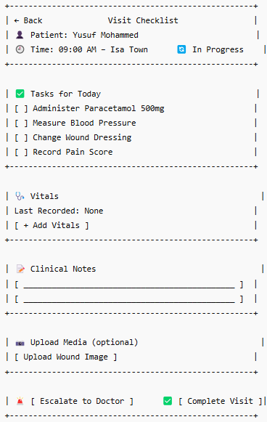
Note to Chiranth: add “Add Clinical notes” button

Screen Behavior
1. Patient Info Banner
- Display-only; auto-fetched from visit assignment
- Includes patient name, time, location
- Clicking this section does not navigate — purely contextual
2. Task Checklist
- Interactive checkboxes
- Each task is dynamically loaded from the care plan
- Required tasks must be checked before allowing "Complete Visit"
- Completed task entries are time-stamped and saved
3. Vitals Section (refer main section )
- Button to open vitals entry screen (manual or device input)
- Shows most recently captured vitals, if any
- If required vitals not entered, system blocks visit completion
4. Clinical Notes (refer main section)
- Free-text input (multi-line)
- Configurable as mandatory or optional based on care type
- Notes auto-saved or saved on action (e.g., Complete Visit)
5. Upload Media
- Optional file/image uploader
- Accepts camera or file system inputs (e.g., JPEG, PNG, PDF)
- File upload failure shows warning; not mandatory unless configured
6. Escalate to Doctor
- Opens escalation screen (reason, vitals, note, optional image)
- Logs escalation event in audit trail
7. Complete Visit
- Disabled until:
  - All required tasks are checked
  - Required vitals (if configured) are recorded
  - Required notes are filled
- On success: marks visit complete and triggers sync/logging

Attributes Description
Field Name | Description | Type | Validation
visit_id | Unique visit identifier | Text | Required
tasks[] | List of care plan tasks | Array of Strings | At least all required tasks must be marked ✔
vitals[] | Captured vitals during visit | Object | Mandatory if marked as required in care plan
notes | Clinical observations entered | Text | Required if care plan demands note entry
media_upload[] | Uploaded photos or documents | File Array | Optional (or mandatory for specific procedures)
escalation_flag | True if an escalation was triggered | Boolean | Automatically logged when escalation event happens
completion_time | Timestamp of visit completion | DateTime | Auto-populated

Messages and Validations
Scenario | Message / Validation
Task checklist incomplete | “Please complete all required tasks before finalizing the visit.”
Required vitals not entered | “Vitals must be recorded before completing this visit.”
Notes field left blank when mandatory | “Clinical observations are required to complete this visit.”
File upload fails | “Upload failed. Please retry or skip if not mandatory.”
Attempt to complete visit without internet (sync) | “Visit will be finalized and synced when you’re back online.”
Escalation triggered | “Escalation sent to assigned supervisor. Continue documenting care.”

Security and Permissions
Action | Required Permission | Roles
View assigned tasks | visit.tasks.view | Caregiver
Check-off task | visit.tasks.update | Caregiver
Record vitals | visit.vitals.add | Caregiver, Nurse
Add notes | visit.notes.add | Caregiver
Upload media | visit.media.upload | Caregiver
Escalate visit | visit.escalation.trigger | Caregiver
Complete visit | visit.complete | Caregiver

Backend API Requirements
Endpoint | Method | Description | Request Payload | Response
/api/visit/tasks/:visit_id | GET | Fetch list of tasks assigned to a visit | visit_id | { tasks: [...] }
/api/visit/tasks/complete | POST | Mark individual task as completed | { visit_id, task_id, caregiver_id } | { status: success }
/api/visit/vitals/add | POST | Add vitals captured during visit | { visit_id, vitals[], timestamp } | { status: success }
/api/visit/notes/add | POST | Add clinical notes | { visit_id, notes, caregiver_id } | { status: saved }
/api/visit/media/upload | POST | Upload image or document | Multipart file + visit_id | { file_url, upload_status }
/api/visit/escalate | POST | Trigger escalation to doctor | { visit_id, reason, caregiver_id, vitals_snapshot } | { escalation_id, status }
/api/visit/complete | POST | Finalize the visit | `{ visit_id,_

Audit Trail
Event | Captured Fields
Task marked completed | task_id, visit_id, caregiver_id, completed_at
Vitals recorded | vitals[], recorded_by, recorded_at, device/manual
Notes submitted | visit_id, caregiver_id, note, submitted_at
Media uploaded | visit_id, file_name, file_type, uploaded_by, timestamp
Escalation triggered | visit_id, caregiver_id, reason, escalated_at
Visit finalized | visit_id, caregiver_id, start_time, end_time, location, completion_time

Error Handling and Edge Cases
Scenario | System Behaviour
API call fails (tasks, notes, vitals) | Show toast: “Action could not be saved. Retrying...” (auto-save locally)
Incomplete checklist but visit completion attempted | Prevent submission; show “All required tasks must be completed.”
Poor network while uploading media | Retry button shown; media saved locally for retry
Escalation API fails | Logs locally and retries; shows: “Escalation will be sent once online.”
Duplicate visit completion attempt | Prevent resubmission; show: “This visit has already been completed.”

My schedule – Mark Arrival

Description
The GPS Check-In/Check-Out screen allows caregivers to mark attendance for home visits using location-verified methods, ensuring Electronic Visit Verification (EVV) compliance. The screen supports GPS-based verification, NFC tag detection, or OTP entry. Location, time, and caregiver identity are recorded for audits, billing, and NHRA/Medicaid regulations.

Instantiation of the Event
- Trigger:
Caregiver selects “Mark Arrival” or “Mark Exit” from the Visit Dashboard
- Entry Points:
  - From Landing Dashboard > Visit Card > Mark Arrival / Mark Exit
  - From Visit Checklist > EVV Verification Button (optional)
- Pre-conditions:
  - Visit must be scheduled for that day and assigned to the caregiver
  - GPS services must be active on the device (or NFC/OTP fallback enabled)
  - Caregiver must be logged in and verified
- Post-conditions:
  - System logs date, time, location, and verification method
  - EVV-compliant entry is created in the visit record
  - Triggers transition to Visit Checklist (on Check-In) or Completion Summary (on Check-Out)

User Interface Design

Screen Layout
UI Component | Description
Header (← Back, Title) | Displays screen title “Visit Verification (EVV)” with back navigation
Patient Info Banner | Shows patient name, visit time, and address
Location Status | Auto-detected GPS coordinates and location accuracy
Verification Method Picker | Radio buttons for selecting GPS, NFC, or OTP-based verification
OTP Entry Field | Conditionally visible if OTP is selected; accepts 6-digit code
Remarks Field | Optional text input to capture visit context or anomalies
Check-In Button | Enabled when GPS/NFC/OTP is validated and active
Check-Out Button | Same as above; used at end of visit
Auto-Timestamp Label | System-generated time at which the action is executed

Wireframe

Screen Behavior
1. Patient Info Banner
- Displays assigned patient’s name, scheduled time, and address
- Read-only; no interaction
- Fetched from visit data context
2. Location Status
- Automatically captures caregiver’s current GPS coordinates
- Displays accuracy (e.g., “4.2 meters”) in real time
- If GPS is off or permission denied → prompt to enable location
- Required only for GPS-based check-in
3. Verification Method
- Single-select radio options:
  - GPS-Based (default): Requires successful geolocation capture
  - NFC Tag: Requires device NFC sensor + valid tag
  - OTP: Requires caregiver to enter code provided by patient/family
- Selecting one toggles the relevant input/display fields
4. OTP Field
- Visible only if “OTP Code Entry” is selected
- Accepts 6-digit numeric input only
- Required if OTP mode is chosen
5. Remarks
- Optional text area
- Used to add context such as “Patient not at home,” “Caregiver arrived late,” etc.
- Shown in visit summary for compliance officers
6. Check-In / Check-Out Buttons
- Only enabled when:
  - Valid location (for GPS mode) or
  - NFC tag is detected or
  - OTP is verified
- On tap:
  - Timestamp is captured
  - Location is stored (for GPS)
  - Visit state is updated (e.g., from "Scheduled" to "In Progress" on check-in)

Attributes Description
Field Name | Description | Type | Validation
verification_method | Selected verification type (GPS, NFC, OTP) | Enum | Required
gps_coordinates | Caregiver’s current lat/long location | Geo Point | Required if method = GPS; accuracy ≤ 50 meters preferred
nfc_tag_id | ID of scanned NFC tag (if used) | String | Required if method = NFC
otp_code | 6-digit code entered by caregiver | String | Required if method = OTP; must match backend-generated code
timestamp | Auto-captured system time when action is performed | DateTime | Required
remarks | Optional comments on the visit | Text | Optional
caregiver_id | ID of the logged-in caregiver | String | Auto-filled
visit_id | ID of the current visit | String | Auto-filled

Messages and Validations
Scenario | Message / Validation
No verification method selected | “Please select a verification method.”
GPS not enabled / denied | “Location permission required for GPS-based verification.”
Location accuracy poor (> 100 meters) | “Low GPS accuracy. Move closer to the site and try again.”
NFC scan failed | “No NFC tag detected. Please try again or switch method.”
OTP not entered when required | “Enter the 6-digit OTP to proceed.”
OTP entered incorrectly | “Invalid OTP. Please check and try again.”
Attempt to Check-In without valid verification | “Verification incomplete. Please complete verification to proceed.”
Successful Check-In/Out | “Check-In recorded at 09:03 AM with GPS verification.”
Timestamp in future or before schedule (edge) | “Invalid timestamp. Please check device clock settings.”

Security and Permissions
Action | Required Permission | Roles
View EVV screen | visit.evv.view | Caregiver
Perform Check-In | visit.evv.checkin | Caregiver
Perform Check-Out | visit.evv.checkout | Caregiver
Submit OTP Verification | visit.evv.otp.verify | Caregiver
Use NFC for EVV | visit.evv.nfc.verify | Caregiver

Backend API Requirements
Endpoint | Method | Description | Request Payload | Response
/api/visit/evv/check-in | POST | Log GPS/NFC/OTP-based check-in | { visit_id, caregiver_id, verification_method, gps_coordinates, otp_code?, nfc_tag_id?, timestamp, remarks } | { status: "success", check_in_time }
/api/visit/evv/check-out | POST | Log GPS/NFC/OTP-based check-out | { visit_id, caregiver_id, verification_method, gps_coordinates, otp_code?, nfc_tag_id?, timestamp, remarks } | { status: "success", check_out_time }
/api/visit/evv/verify-otp | POST | Validate OTP before check-in/out | { visit_id, otp_code } | { status: "valid" / "invalid" }

Audit Trail
Event | Captured Fields
Visit Checked-In | visit_id, caregiver_id, timestamp, method, location, remarks
Visit Checked-Out | visit_id, caregiver_id, timestamp, method, location, remarks
OTP Verified | visit_id, caregiver_id, otp_code, verification_result, timestamp
NFC Tag Used | visit_id, caregiver_id, nfc_tag_id, timestamp

Error Handling and Edge Cases
Scenario | System Behaviour
GPS disabled or permission denied | Prompt user: “Location access required for GPS verification.”
OTP invalid | Show: “Invalid OTP. Please try again or contact admin.”
NFC not detected | Message: “No NFC tag found. Hold device closer or use another method.”
Location accuracy too low | Show warning: “GPS signal too weak. Please retry in 30 seconds.”
Check-in attempted twice for same visit | Prevent; show: “You have already checked in for this visit.”
Offline mode (no network) | Save check-in/check-out data locally; queue for sync
Timestamp mismatch (future or beyond visit hours) | Show: “Time must be within visit window. Please verify system clock.”
Backend failure | Show: “Unable to log visit at this time. Data will be retried automatically.”

Start Visit – Vitals Entry / Device Sync

Description
The Vitals Entry / Device Sync screen allows caregivers to capture key vital signs for a patient during a home visit. Caregivers can either manually input vitals such as BP, temperature, pulse, etc., or sync with a connected Bluetooth/IoT device. The data is stored as part of the visit record and contributes to the care plan validation, escalation decisions, and audit trail.

Instantiation of the Event
- Trigger:
  - Caregiver taps on “+ Add Vitals” from the Visit Checklist screen
- Entry Points:
  - From Visit Checklist > Add Vitals
- Pre-conditions:
  - The caregiver must be actively in a visit (status = In Progress)
  - Device Bluetooth must be enabled if using Device Sync
  - A patient must be assigned to the visit
- Post-conditions:
  - Vitals are saved to the patient’s visit record
  - Source (manual/device) and timestamp are logged
  - Caregiver returns to Visit Checklist after saving

User Interface Design

Screen Layout
UI Component | Description
Header (← Back, Title) | Allows navigation back to checklist; displays title “Vitals Entry”
Patient Info Banner | Displays patient name, visit time, location
Entry Mode Toggle | Radio buttons to select between Manual or Device Sync mode
Vitals Fields | Text inputs for Temp, BP, Pulse, SpO₂, Resp. Rate, Glucose
Measured At | Auto-filled with current timestamp; editable dropdown
Source | Dropdown to select entry source (Manual or Device name)
Save Vitals Button | Validates and saves all vitals entered
Bluetooth Status | Shows connection status of paired device (only in Device Sync mode)
Resync Device Button | Available when in Device Sync mode to retry fetching from Bluetooth device

Wireframe
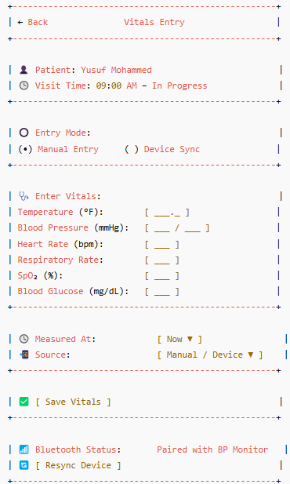

Screen Behavior
1. Entry Mode Toggle (Manual / Device Sync)
- Caregiver selects one mode before entering/syncing vitals
- Default is “Manual Entry”
- Selecting “Device Sync” triggers Bluetooth pairing and attempts to pull data
- If device is not paired, a warning or guide is shown
2. Vitals Fields
- All fields are numeric and accept only positive values
- Only BP and Temperature are mandatory if care plan specifies
- When in Device Sync mode:
  - Fields are auto-filled once sync is successful
  - Caregiver may manually override values if needed
3. Measured At (Timestamp)
- Auto-filled with current date and time
- Caregiver can adjust manually via time picker if needed
- Used to track when vitals were measured (vs. when entered)
4. Source
- Defaults to “Manual” for manual entries
- If device sync is successful, displays the device name (e.g., “Omron BP Monitor”)
5. Save Vitals
- Validates all required fields
- Triggers backend API to save to visit record
- Disabled if required fields are blank or invalid
6. Bluetooth Status & Resync Device
- Only visible when Entry Mode = Device Sync
- Shows whether a device is connected or not
- Caregiver can click Resync Device to retry fetching data
- Fails gracefully with retry options and offline fallback

Attributes Description
Field Name | Description | Type | Validation
entry_mode | Manual or Device Sync toggle | Enum | Required; must be either 'manual' or 'device'
temperature | Patient’s body temperature (°F or °C) | Float | Must be > 90 and < 110°F
bp_systolic | Upper BP value (mmHg) | Integer | Must be between 90 and 200
bp_diastolic | Lower BP value (mmHg) | Integer | Must be between 50 and 120
pulse | Heart rate (bpm) | Integer | Must be between 40 and 180
respiratory_rate | Breaths per minute | Integer | Must be between 10 and 40
spo2 | Oxygen saturation percentage | Integer | Must be between 70 and 100
blood_glucose | Blood glucose (mg/dL) | Integer | Must be between 50 and 400 (optional)
measured_at | Timestamp of when vitals were recorded | Datetime | Defaults to current time; editable
source | Source of vitals data (Manual or Device name) | Text | Required

Messages and Validations
Scenario | Message / Validation
Required field left blank (e.g., BP, Temp) | “Please enter all required vitals before saving.”
Invalid numeric input (e.g., negative values) | “Please enter valid values for vitals.”
Device not paired or fails to sync | “No device connected. Please ensure Bluetooth is on and try again.”
Sync success but values are abnormal | “Vitals recorded successfully. Please review any out-of-range values.”
Save successful | “Vitals saved to visit record.”

Security and Permissions
Action | Required Permission | Roles
View vitals entry screen | visit.vitals.view | Caregiver, Nurse
Add vitals | visit.vitals.add | Caregiver, Nurse
Sync device | visit.vitals.sync_device | Caregiver
Edit timestamp | visit.vitals.edit_time | Caregiver (optional)

Backend API Requirements
Endpoint | Method | Description | Request Payload | Response
/api/visit/vitals/add | POST | Save vitals to the visit record | { visit_id, vitals[], measured_at, source, caregiver_id } | { status: "success" }
/api/visit/device/sync | POST | Trigger pull from connected device (if manual trigger) | { visit_id, device_id, caregiver_id } | { vitals[], device_name, timestamp }
/api/visit/vitals/latest/:id | GET | Fetch last recorded vitals for context | visit_id | { vitals[], recorded_at }

Audit Trail
Event | Captured Fields
Vitals added manually | caregiver_id, visit_id, vitals[], measured_at, source=Manual
Vitals synced from device | device_id, vitals[], timestamp, caregiver_id, visit_id
Bluetooth resync attempt | device_id, attempt_time, success/failure, caregiver_id

Error Handling and Edge Cases
Scenario | System Behaviour
Vitals field left blank (required) | Display inline message: “Please enter all required vitals.”
Sync attempt fails (device disconnected) | Show: “Unable to connect to device. Please check Bluetooth and retry.”
Out-of-range value entered (e.g., BP 250/150) | Warning toast: “Unusual reading. Please verify before saving.”
No device paired when "Device Sync" selected | Message: “No device detected. Switch to manual entry or connect a device.”
Offline entry | Saves data locally and shows “Vitals will sync once you’re online.”
Duplicate sync value detected | Prompt: “Vitals from device already recorded. Replace existing values?”

Start Visit – Care Plan Notes / Progress Remarks

Description
The Clinical Notes screen allows caregivers to enter structured, categorized notes during a home visit. Each entry is tied to a predefined note type such as General Observation, Progress Update, Mental Status, etc. Caregivers can add multiple note types, attach media, and log observations with timestamps for audit, care coordination, and compliance purposes.

Instantiation of the Event
- Trigger:
  - Caregiver taps “Enter Notes” or navigates from Visit Checklist > Clinical Notes
- Entry Points:
  - Visit Checklist screen
  - Direct quick access from the dashboard (optional shortcut)
- Pre-conditions:
  - Visit must be in progress (visit_status = In Progress)
  - Patient assigned to caregiver
  - Care plan contains associated documentation requirements (optional)
- Post-conditions:
  - One or more categorized notes saved to the visit log
  - Associated media (if any) uploaded and linked to each note
  - Audit trail updated with timestamps and user details
  - Visit ready for finalization or review

User Interface Design

Screen Layout
UI Component | Description
Header (← Back, Title) | Navigation and screen name “Clinical Notes”
Patient Banner | Shows patient name, time window, and location
Notes Sections (repeatable) | One or more collapsible note sections by type (e.g., Observation, Progress)
Note Type Header | Shows the selected note type (e.g., “Mental Status”)
Note Text Area | Multi-line input for clinical remarks
Media Upload Button | Upload photo/document relevant to the specific note section
Timestamp | Auto-filled “Recorded At” field; editable if allowed
Add Another Note Type Button | Opens a picker to add more note categories (disabled if all are used)
Save All Notes Button | Saves all note entries, media, and timestamps in a structured format

Wireframe
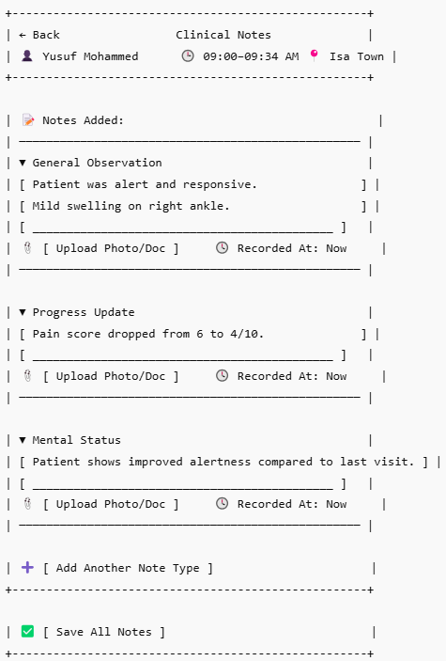

Screen Behavior
1. Note Type Header (e.g., General Observation, Progress Update)
- Displayed as a non-editable section title
- Only one section allowed per type
- Type is locked once added (cannot be changed mid-entry)
- Caregiver can collapse/expand sections for readability
2. Note Text Area (per section)
- Multi-line input
- Required if the corresponding note type is marked mandatory (by care plan or org policy)
- Text auto-saves locally until saved officially
- Can trigger word limit warnings (min 10 words, max 1000 optional)
3. Attach Media (per section)
- Optional image/PDF attachment
- Accepts camera, file picker, or scanner
- Media is linked only to that note type
- If upload fails, retry option appears without losing note text
4. Recorded At
- Auto-filled with current timestamp
- Editable via time picker (if enabled in config)
- Validated not to be in future or before visit start time
5. Add Another Note Type
- Opens modal/bottom sheet with available note types
- Already added note types are disabled or hidden
- Once selected, a new note block is added to the screen dynamically
6. Save All Notes
- Validates:
  - At least one note present
  - Required note types (if configured) must be filled
  - Valid timestamp range
  - File upload completed or retried
- On success: All notes + attachments + timestamps are saved and logged in the visit

Attributes Description
Field Name | Description | Type | Validation
note_type | Category of note (e.g., Observation, Progress) | Enum | Required; must be unique per screen
note_text | Free-text area for caregiver's observations | Text | Required if configured; min 10 characters; no special characters beyond basic
attachment | Optional media upload (image/doc) | File | Optional; max 10MB; allowed: JPG, PNG, PDF
recorded_at | Timestamp of note entry | Datetime | Defaults to now; editable; must be between visit start and now
caregiver_id | Auto-populated logged-in user ID | String | Required

Messages and Validations
Scenario | Message / Validation
Note text missing (required type) | “Please enter a note for required section: [Note Type].”
Invalid timestamp (e.g., future date) | “Recorded time must be within the visit duration.”
Attempt to add duplicate note type | “This note type has already been added.”
Attachment upload fails | “Upload failed. Please retry or skip the file for now.”
All validations pass | “Notes saved successfully and linked to patient visit.”
Attempt to save with no notes | “Please enter at least one note to save.”

Security and Permissions
Action | Required Permission | Roles
View Clinical Notes Screen | visit.notes.view | Caregiver, Nurse
Add/Edit Note Text | visit.notes.add | Caregiver, Nurse
Upload Attachments | visit.notes.upload_media | Caregiver
Edit Timestamp | visit.notes.edit_timestamp | Caregiver (if allowed)
Save Notes | visit.notes.save | Caregiver

Backend API Requirements
Endpoint | Method | Description | Request Payload | Response
/api/visit/notes/add | POST | Save one or more categorized clinical notes | { visit_id, caregiver_id, notes: [{ note_type, note_text, recorded_at, file_url }] } | { status: "success", saved_count: X }
/api/visit/notes/attachments/upload | POST | Upload an image or document linked to a note type | FormData: visit_id, note_type, file (JPG/PNG/PDF) | { file_url, upload_status: "success" }
/api/visit/notes/types/available | GET | Retrieve allowed note categories | visit_id | { types: ["General", "Progress", ...] }

Audit Trail
Event | Captured Fields
Clinical Note Added | visit_id, note_type, caregiver_id, recorded_at, note_text
Attachment Uploaded | file_name, file_type, note_type, visit_id, caregiver_id, timestamp
Timestamp Edited | old_timestamp, new_timestamp, note_type, caregiver_id, edit_time
Note Type Section Added | note_type, caregiver_id, visit_id, timestamp

Error Handling and Edge Cases
Scenario | System Behaviour
Duplicate note type added | Show inline: “This note type has already been added.”
Note text left blank in required section | Prevent save; highlight missing section with “Note required.”
Attachment upload fails | Display retry button; save note text locally until upload succeeds
Invalid timestamp (e.g., future or before visit) | Show: “Invalid time selected. Please choose a valid visit time.”
Offline entry (no internet) | Save note locally with sync queue flag; show: “Notes will sync when online.”
Backend failure on save | Show error toast: “Could not save notes. Please try again.”; log locally
Partial submission (e.g., 2 notes saved, 1 failed) | Confirm saved notes, list failed ones with reason, and allow retry per section

Start Visit – Escalate to Doctor

Description
The Emergency Escalation screen allows caregivers to instantly report critical patient conditions (e.g., collapse, severe vitals, medication reaction) to assigned supervisors or doctors. The screen collects the reason, optional remarks and media, and sends multi-channel alerts (app, SMS, phone call). A vitals snapshot is auto-attached for clinical context.

Instantiation of the Event
- Trigger:
Caregiver taps the red “Emergency” button from the Start Visit screen.
- Entry Points:
  - From Start Visit > Escalate to Doctor
  - Optional shortcut on the top header during a visit (if configured)
- Pre-conditions:
  - Visit must be in progress (visit_status = In Progress)
  - Patient must be assigned to caregiver
  - Vitals data should be available (if not, show placeholder or prompt)
- Post-conditions:
  - Escalation is logged in the system
  - Notifications are sent to the assigned doctor/supervisor via configured channels
  - Visit record is marked with escalation event (for audit/tracking)
  - Optionally triggers immediate call if enabled

User Interface Design

Screen Layout
UI Component | Description
Header (← Back, Title) | Navigates back to checklist; shows title “Emergency Escalation”
Patient Info Banner | Shows patient name, visit time, location
Reason for Escalation | Radio buttons; predefined list of emergency types
Additional Remarks | Optional free-text input for clinical context or situation description
Attachment Upload | Optional media (e.g., wound image, surrounding environment, prescription)
Auto-attached Vitals | Read-only summary of most recent vitals entered
Notification Method Options | Toggle checkboxes for App Alert, SMS, Auto-call
Confirm & Trigger Button | Final action to submit escalation request, alert recipients, and log audit

Wireframe -
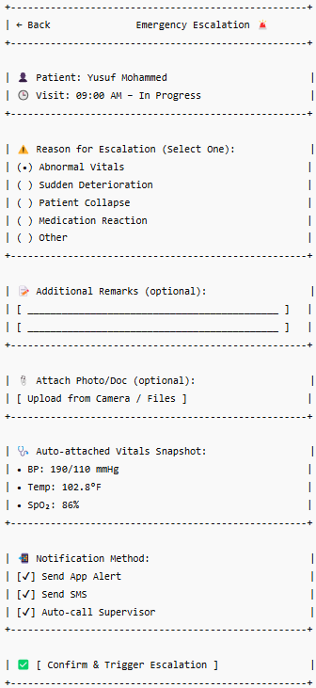

Screen Behavior
1. Reason for Escalation
- Mandatory single-select radio button
- Selecting a reason enables the submission flow
- Mapped to escalation routing logic (e.g., notify nurse vs. doctor)
2. Additional Remarks
- Optional free-text field for context
- Minimum character length encouraged if “Other” is selected
- Can auto-fill common phrases if configured
3. Attach Photo/Document
- Optional; accepts image or PDF upload
- Upload is per escalation (not saved to patient history unless submitted)
- Can retry if upload fails
4. Vitals Snapshot
- Auto-loaded from the latest saved vitals during the visit
- Read-only; shown for reference to receiver
- If vitals not yet recorded → show “No vitals available”
5. Notification Method (Checkboxes)
- All 3 methods (App Alert, SMS, Auto-call) are selected by default
- Caregiver can uncheck any
- Auto-call may trigger dialer directly or server-side IVR based on setup
6. Confirm & Trigger Escalation
- Validates mandatory fields (reason at minimum)
- Sends escalation payload to API
- Displays success message and logs event in audit trail
- Optionally returns caregiver to Visit Checklist

Attributes Description
Field Name | Description | Type | Validation
reason | Selected escalation type | Enum | Required
remarks | Free-text notes from caregiver | Text | Optional unless reason = “Other” (then required)
attachment | Optional image or document | File | Optional; max 10MB; file types: JPG, PNG, PDF
vitals_snapshot | Latest vitals data from visit | Object | Auto-fetched; read-only
notification_method[] | Selected notification types | Array<Enum> | At least one method must be selected (App/SMS/Call)
caregiver_id | Logged-in caregiver submitting escalation | Text | Required
visit_id | Associated visit ID | Text | Required

Messages and Validations
Scenario | Message / Validation
No reason selected | “Please select a reason for escalation.”
“Other” selected with empty remarks | “Please provide additional details for ‘Other’.”
No notification method selected | “Select at least one notification method (App, SMS, or Call).”
Upload failure | “Media upload failed. Please retry or skip attachment.”
Successful escalation | “Escalation triggered successfully. Help is on the way.”
Vitals missing | “No vitals available. Escalation will proceed without snapshot.”

Security and Permissions
Action | Required Permission | Roles
View Escalation Screen | escalation.view | Caregiver
Submit Escalation Request | escalation.trigger | Caregiver
Upload Escalation Attachment | escalation.attachment.upload | Caregiver
Auto-call Trigger (if allowed) | escalation.auto_call | Caregiver, Supervisor

Backend API Requirements
Endpoint | Method | Description | Request Payload | Response
/api/escalation/trigger | POST | Trigger escalation alert | { visit_id, caregiver_id, patient_id, reason, remarks, vitals_snapshot, notification_methods[], timestamp, attachment_url (optional) } | { status: "success", escalation_id }
/api/escalation/attachment/upload | POST | Upload image or document for escalation | FormData: visit_id, caregiver_id, file (JPG/PNG/PDF) | { file_url, status: "success" }
/api/escalation/notify | POST | Trigger backend-based SMS/Call/Push notification | { escalation_id, methods[], target_roles[], message_template } | { status: "notified", methods_triggered: [] }

Audit Trail
Event | Captured Fields
Escalation triggered | escalation_id, caregiver_id, patient_id, visit_id, reason, timestamp
Attachment uploaded | file_name, file_type, uploaded_by, visit_id, linked_escalation_id
Notification sent | escalation_id, notification_channel, recipient_id, sent_at
Auto-call initiated | escalation_id, supervisor_id, call_status, call_time

Error Handling and Edge Cases
Scenario | System Behaviour
No reason selected | Show: “Please select a reason for escalation.”; block submission
No notification method selected | Show: “At least one notification method must be selected.”
Upload fails | Prompt retry with: “Upload failed. Try again or skip this step.”
Vitals snapshot unavailable | Allow escalation, but show: “Vitals could not be attached. Proceeding anyway.”
Backend fails to notify supervisor | Show non-blocking alert: “Escalation logged, but notification failed. Retry manually.”
Network disconnect before submit | Save locally with a retry queue and show: “Will escalate once back online.”
Auto-call permission denied | Suppress call; show: “Auto-call disabled for this caregiver. Alert sent via SMS/App.”

Documentation – Image/Document Upload

Description
The Image/Document Upload screen enables caregivers to attach relevant media to a patient visit, such as wound images, prescriptions, progress forms, or lab results. These files are tagged with metadata (type, description, timestamp) and are securely linked to the visit for audit, clinical review, and compliance tracking.

Instantiation of the Event
- Trigger:
Caregiver taps “Upload Image/Document” from within the visit (e.g., Visit Checklist or Clinical Notes)
- Entry Points:
  - From Visit Checklist > Upload Media
  - From Clinical Notes > Upload Photo/Doc
  - From Emergency Escalation > Upload File
- Pre-conditions:
  - An active or completed visit must be in context
  - Caregiver must have file upload permission
  - Device must have camera or file access enabled
- Post-conditions:
  - Media file is uploaded and stored securely
  - Linked to the appropriate visit ID and document type
  - Available in visit summary or patient documentation history
  - Entry logged in audit trail

User Interface Design

Screen Layout
UI Component | Description
Header (← Back, Title) | Allows navigation back to the previous screen; displays screen title
Patient Info Banner | Displays name, visit time, location for reference
Document Type Selector | Mandatory radio buttons or dropdown to categorize file (e.g., Wound, Prescription)
Description Textbox | Optional; free-text field for additional file context
Upload File Section | Button to open camera or file picker; accepts image or PDF
File Preview Area | Thumbnail preview shown for image files
Timestamp Field | Auto-filled with current time; editable if required
Uploaded By Label | Shows the caregiver’s name; read-only
Save Upload Button | Commits file and metadata to visit record

Wireframe
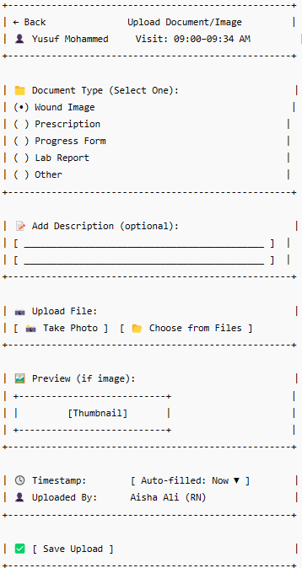

Screen Behavior
1. Document Type
- Mandatory selection (radio/dropdown)
- Determines how the file is categorized in the visit record
- Certain types (like “Wound Image”) may trigger additional validations (e.g., file type must be image)
2. Add Description
- Optional free-text field
- Used to provide context (e.g., “wound on left leg, before cleaning”)
- If Document Type = Other, this becomes mandatory
3. Upload File
- Opens camera or file picker
- Accepts: .jpg, .jpeg, .png, .pdf
- Image previews shown if applicable
- Uploads to temporary cache; permanent only on Save
4. Preview (if image)
- Preview shown in thumbnail layout
- Clicking it (optional feature) can open a full preview
5. Timestamp
- Auto-filled with system time
- Can be edited using a time picker (if editable is enabled)
- Validated not to be in the future or outside visit time bounds
6. Uploaded By
- Auto-fetched caregiver name/ID
- Read-only; not editable
7. Save Upload
- Validates:
  - File present
  - Document type selected
  - Description if required
- Saves file to server and links metadata to visit

Attributes Description
Field Name | Description | Type | Validation
document_type | Category of document being uploaded | Enum | Required
description | Additional context/details | Text | Optional; required if document_type = Other
file | Uploaded file (image or document) | File | Required; type = JPG/PNG/PDF; size ≤ 10MB
timestamp | When the file was captured/uploaded | DateTime | Defaults to now; must not be in future
uploaded_by | Logged-in caregiver | Text | Auto-filled, read-only

Messages and Validations
Scenario | Message / Validation
No document type selected | “Please select a document type.”
Description left blank with type = Other | “Please enter a description for ‘Other’ document type.”
File not selected | “Please upload an image or document before saving.”
Unsupported file format | “Unsupported file format. Please upload JPG, PNG, or PDF.”
File exceeds max size | “File is too large. Maximum allowed size is 10 MB.”
Timestamp is invalid | “Timestamp cannot be in the future.”
Successful upload | “Document uploaded and linked to visit successfully.”
Upload failed (network issue) | “Upload failed. Please try again or check your connection.”

Security and Permissions
Action | Required Permission | Roles
View upload screen | visit.media.view | Caregiver, Nurse
Upload image/document | visit.media.upload | Caregiver, Nurse
Edit timestamp (if enabled) | visit.media.edit_timestamp | Caregiver
Save uploaded metadata | visit.media.save | Caregiver

Backend API Requirements
Endpoint | Method | Description | Request Payload | Response
/api/visit/media/upload | POST | Uploads file to the system | FormData: visit_id, document_type, caregiver_id, file (jpg/png/pdf) | { file_url, status: "success" }
/api/visit/media/save-metadata | POST | Saves metadata with file reference | { visit_id, document_type, file_url, description, timestamp, caregiver_id } | { status: "success", media_id }
/api/visit/media/delete/:media_id | DELETE | (Optional) Deletes a media file before saving | media_id | { status: "deleted" }

Audit Trail
Event | Captured Fields
File uploaded | file_name, file_type, visit_id, uploaded_by, timestamp
Metadata saved | document_type, description, file_url, visit_id, caregiver_id, timestamp
Timestamp manually edited | original_time, new_time, edited_by, edit_time

Error Handling and Edge Cases
Scenario | System Behaviour
No file selected | Show inline message: “Please upload an image or document before saving.”
No document type selected | Prevent save; prompt: “Select a document type.”
Unsupported file format | Alert: “Only JPG, PNG, and PDF files are supported.”
File too large (>10MB) | Block upload; show: “File exceeds maximum allowed size of 10MB.”
Upload interrupted (network loss) | Store locally (if offline mode supported) and retry when back online
Timestamp out of range | Warn user: “Please enter a valid timestamp within the visit timeframe.”
Backend failure on metadata save | Show error toast: “Upload failed. Please try again later.”; allow retry

Communication – Supervisor Chat

Description
The Supervisor Chat screen enables real-time, secure, and auditable communication between caregivers and designated supervisors, doctors, or admins. It is used during patient visits to escalate concerns, clarify treatment steps, or share observations like images or vitals. All messages are logged as part of the visit record for compliance and review.

Instantiation of the Event
- Trigger:
Caregiver taps the “Chat with Supervisor” button during an active visit
- Entry Points:
  - From Floating Chat Icon in the tile
- Pre-conditions:
  - Active internet connection
  - Visit must be in progress or just completed
  - Caregiver and supervisor/doctor must be assigned to the same visit
  - Secure login session active
- Post-conditions:
  - Messages and files are stored under the visit record
  - Supervisor receives notifications and responds in real-time
  - Messages are available for later audit and clinical review

User Interface Design

Screen Layout
UI Component | Description
Header (← Back, Title) | Navigation and title showing recipient name (e.g., “Chat with Supervisor”)
Patient Visit Context | Displays patient name, visit time, and location for context
Message Thread Area | Scrollable chat bubble view with timestamps, sender indicators
File Attachments | Inline previews (images, PDFs) with "View" option
Input Text Field | Where the caregiver types messages
Attachment Button (📎) | Opens media picker for uploading images, PDFs, or voice messages
Voice Message Option (🎤) | Optional, records and sends audio notes if allowed
Send Button (➤) | Enabled only when there is a message or attachment ready

Wireframe
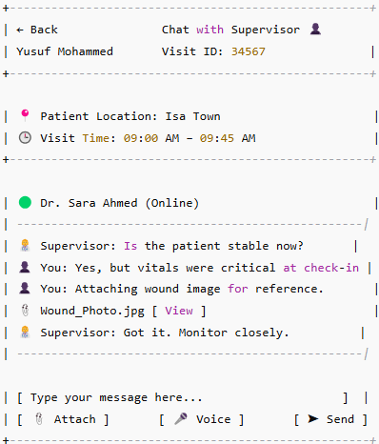

Screen Behavior
1. Chat Header (← Back, Chat with Supervisor)
- Displays the name/role of the assigned recipient (supervisor/doctor)
- Includes a back button to return to the previous visit screen
- If the user is offline, shows "Offline" indicator beside supervisor’s name
2. Visit Context Banner
- Displays patient's name, scheduled time, and visit location
- Fetched from current visit record
- Read-only, for context only
3. Chat Thread (Message Area)
- Scrollable feed showing all messages with:
  - Sender (You vs. Supervisor)
  - Timestamp
  - Inline images/files
- Supports basic markdown or message formatting if enabled
4. Message Input Field
- Multi-line text box
- Allows emojis, up to 1000 characters
- Empty input disables the Send button
5. Attachment Button (📎)
- Opens media picker (camera, gallery, files)
- Accepts: .jpg, .png, .pdf, .mp3
- File preview shown in the thread after successful upload
6. Voice Button (🎤)
- Optional; allows caregivers to record short audio messages
- Saved as .mp3 and shown with playback option
- Disabled in offline mode or if permission not granted
7. Send Button (➤)
- Enabled when there is text or an attachment selected
- On tap:
  - Sends message via real-time channel (e.g., WebSocket or API fallback)
  - Auto-scrolls thread to latest message
  - Timestamp and delivery status added

Attributes Description
Field Name | Description | Type | Validation
message_text | Message typed by caregiver | Text | Max 1000 chars; cannot be empty if no attachment
attachment | File attached to message | File | Optional; type JPG, PNG, PDF, MP3; max size 10 MB
timestamp | Message creation time | DateTime | Auto-filled
sender_id | Caregiver ID | String | Auto-filled
receiver_id | Supervisor/doctor ID | String | Auto-filled
visit_id | Associated visit ID | String | Required
message_type | Text, Image, Document, Voice | Enum | Required

Messages and Validations
Scenario | Message / Validation
Empty message and no attachment | “Please enter a message or add a file to send.”
File upload fails | “Upload failed. Please try again or check your connection.”
Unsupported file type | “This file type is not supported. Please upload JPG, PNG, PDF, or MP3.”
File too large | “File exceeds maximum allowed size (10 MB).”
Offline mode | “You are offline. Messages will be queued and sent once online.”
Message sent successfully | Message appears instantly in thread with timestamp and ✅ tick
Supervisor offline | Show “Supervisor is offline. You can still send messages.”

Security and Permissions
Action | Required Permission | Roles
View chat screen | chat.view | Caregiver, Supervisor
Send text message | chat.message.send | Caregiver, Supervisor
Upload attachments | chat.attachment.upload | Caregiver, Supervisor
Receive real-time notifications | chat.notifications.receive | Supervisor

Backend API Requirements
Endpoint | Method | Description | Request Payload | Response
/api/chat/send-message | POST | Send a text message or message with attachment | { visit_id, sender_id, receiver_id, message_text, message_type, timestamp, attachment_url (if any) } | { status: "sent", message_id, timestamp }
/api/chat/upload-attachment | POST | Upload a media file | FormData: visit_id, sender_id, file | { file_url, status: "uploaded" }
/api/chat/thread/:visit_id | GET | Retrieve existing message thread for visit | visit_id | { messages: [ ... ] }

Audit Trail
Event | Captured Fields
Message Sent | message_id, sender_id, receiver_id, message_text, timestamp, visit_id
Attachment Uploaded | file_name, file_url, sender_id, visit_id, uploaded_at
Message Viewed (optional) | message_id, receiver_id, viewed_at
Supervisor Responded | message_id, sender_id, visit_id, response_text, timestamp

Error Handling and Edge Cases
Scenario | System Behaviour
No internet connection | Show: “You are offline. Messages will be sent once you're back online.”
Attachment upload fails | Show: “Upload failed. Please try again.” with retry option
Message send failure (timeout/server error) | Message marked as unsent with retry icon
Unsupported file type uploaded | Show: “Unsupported file type. Use JPG, PNG, PDF, or MP3.”
File exceeds size limit | Prevent upload; show: “File size exceeds 10MB limit.”
Recipient is offline | Allow message; show: “Supervisor is offline. They’ll be notified when they’re back.”
Duplicate message (retry resend) | Allow retry with same content but prevent duplication in thread visually

Alerts & Messages – Notifications Center

Description
The Notifications Center is a centralized hub where caregivers can view all system-triggered alerts related to their assigned visits, tasks, shifts, and system-wide updates. This ensures caregivers never miss time-sensitive reminders, escalations, or schedule changes. Notifications are organized chronologically and can be filtered by type for easy navigation.

Instantiation of the Event
- Trigger:
User taps the 🔔 bell icon or “Notifications” menu item in the app
- Entry Points:
  - From top bar icon (bell symbol)
  - From main menu → Alerts & Messages
  - From floating red badge (e.g., “3 new alerts”)
- Pre-conditions:
  - User must be logged in
  - Push or in-app notifications must be enabled
  - Notifications should have been generated for the caregiver based on activity
- Post-conditions:
  - Tapping on a notification route to the appropriate screen (e.g., visit, checklist, shift calendar)
  - Notifications are marked as read
  - Any escalations or visit alerts are acknowledged in the backend (audit/compliance logging)

User Interface Design

Screen Layout
UI Component | Description
Header (← Back, Title) | Navigates back to the home screen; displays “Notifications Center”
Search Bar | Allows caregivers to search by patient name, alert type, or keyword
Filter Dropdown | Filters by alert type: All, Visit Reminders, Task Escalations, Shift Changes
Sort Dropdown | Allows sorting notifications by newest/oldest or urgency
Date Group Labels | Divides notifications into “Today”, “Yesterday”, “Earlier”
Notification Cards | Shows type, short message, patient/visit context, and quick action text
Tap Action | Tapping a card opens related screen (visit details, checklist, calendar, etc.)

Wireframe
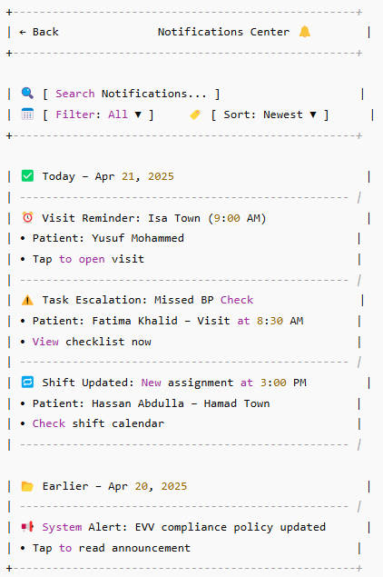

Screen Behavior
1. Search Bar
- Allows keyword search on patient names, notification titles, or descriptions.
- Live filtering – updates list as user types.
- Clears input on tap of reset/cancel icon.
- If no results, shows “No notifications found.”
2. Filter Dropdown
- Options: All, Visit Reminders, Task Escalations, Shift Changes, System Alerts.
- Changing filter refreshes notification list to show only selected category.
- Default: All.
3. Sort Dropdown
- Options: Newest First, Oldest First, By Urgency.
- Used to re-order notification cards.
- Default: Newest First.
4. Date Group Labels
- Divides the notification list into logical groups like:
  - Today, Yesterday, Earlier
- Dynamically determined based on system date.
5. Notification Cards
- Each card displays:
  - Icon (type indicator)
  - Title (e.g., Visit Reminder)
  - Context (e.g., patient name, visit time)
  - Action line (e.g., “Tap to open visit”)
- Tapping a card:
  - Marks the notification as read
  - Navigates user to the relevant screen (Visit Checklist, Shift Calendar, Policy Page, etc.)
6. Read Status
- Visual indication: bold for unread, normal for read
- On tap → status is changed to read and acknowledged in backend
- Read/unread state persisted between sessions

Attributes Description
Field Name | Description | Type | Validation
notification_id | Unique identifier for each alert | String | Required
notification_type | Visit Reminder, Escalation, Shift Change, System | Enum | Required
title | Short description/title of the alert | String | Max 100 chars
description | Detailed body/message of the alert | Text | Optional; Max 300 chars
patient_name | Associated patient’s name (if applicable) | String | Optional (not for system alerts)
timestamp | Date and time when the alert was generated | DateTime | Required
is_read | Boolean flag to track if the alert was opened | Boolean | Default = false
linked_screen | Where to route the user on tap (e.g., checklist) | Enum | Required if actionable

Messages and Validations
Scenario | Message / Validation
No notifications available | “You're all caught up! No new alerts.”
No search results found | “No notifications match your search.”
Invalid or missing linked screen on tap | “This alert is no longer active or linked. Please refresh.”
Filter returns zero results | “No alerts in this category yet.”
Attempt to resend old system alert (debug only) | “This message has already been acknowledged.”

Security and Permissions
Action | Required Permission | Roles
View notifications center | notifications.view | Caregiver, Nurse
Fetch user notifications | notifications.fetch | Caregiver, Nurse
Mark notification as read | notifications.update_status | Caregiver, Nurse
Access linked visit/task/shift | notifications.navigate | Caregiver, Nurse

Backend API Requirements
Endpoint | Method | Description | Request Payload | Response
/api/notifications/list | GET | Fetch all notifications for the logged-in user | Query Params: user_id, filter_type?, sort_order? | { notifications: [ ... ] }
/api/notifications/mark-read/:id | PATCH | Mark a specific notification as read | Path Param: notification_id | { status: "success", updated_at }
/api/notifications/unread-count | GET | Get count of unread notifications for badge | Query Param: user_id | { unread_count: number }
/api/notifications/by-type | GET | Filter notifications by type | Query Params: user_id, type (visit, shift, system, etc.) | { notifications: [ ... ] }

Audit Trail
Event | Captured Fields
Notification Viewed | notification_id, user_id, viewed_at, notification_type, linked_entity
Notification Action Taken | notification_id, user_id, action_type, navigated_to, timestamp
Unread Count Fetched | user_id, count_returned_at

Error Handling and Edge Cases
Scenario | System Behaviour
API fails to fetch notifications | Show: “Unable to load notifications. Please try again.”
No notifications returned | Display empty state: “You're all caught up!”
Mark as read fails (server/network issue) | Keep item visually unread; show: “Failed to update. Tap again to retry.”
Linked screen is no longer available | Show: “This action is no longer active. Please refresh or contact admin.”
Filter returns no results | Show: “No notifications found for selected category.”
Network loss during list fetch | Show: “You're offline. Showing last synced alerts.” (if cached), or retry option

Sync Queue – Sync Status & Retry Screen

Description
The Offline Sync Status & Retry screen provides caregivers with a centralized view of all pending offline submissions—such as visit check-ins, vitals, attachments, and notes—that were recorded without an internet connection. Caregivers can manually retry syncing individual items or bulk sync all pending data once connectivity is restored. This ensures data integrity, submission tracking, and EVV/NHRA compliance.

Instantiation of the Event
- Trigger:
  - System detects user is offline and logs unsynced actions
  - User navigates to sync status screen manually or via alert badge
- Entry Points:
  - From app dashboard: “Offline Items (🔄)” badge
  - From settings menu > Offline Sync Center
  - Auto-prompt after a failed sync attempt
- Pre-conditions:
  - App is in offline mode or was recently offline
  - At least one item pending sync must exist
  - Caregiver is logged in and session is active
- Post-conditions:
  - Items successfully synced are removed from the pending list
  - Failures are logged for retry with appropriate messages
  - Removal is confirmed with the user and tracked in audit logs

User Interface Design

Screen Layout
UI Component | Description
Header (← Back, Title) | Navigation + title bar showing “Offline Sync Status”
Sync Status Label | Indicates current connectivity (Online/Offline) and number of pending items
Sync Item Cards | Show each pending action (e.g., Check-In, Vitals, Note, Upload)
Item Metadata | Timestamp, patient/visit info, reason for failure
Retry Button (🔄) | Manually triggers sync for that item
Remove Button (❌) | Prompts user for confirmation, removes the item if confirmed
Sync All Now Button | Triggers bulk sync of all items in the queue
Auto-Sync Toggle | Allows user to enable/disable auto-retry on reconnect

Wireframe
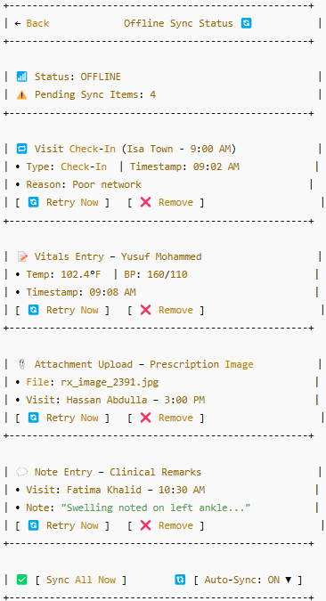

Screen Behavior
1. Sync Status Label
- Displays real-time connectivity status: Online or Offline
- When Online, triggers optional background auto-sync (if enabled)
- When Offline, disables “Sync Now” actions (greyed out)
2. Sync Item Cards
- Each card displays:
  - Action Type (e.g., Check-In, Vitals Entry, Note, File Upload)
  - Context Info: Patient name, visit time, timestamp of submission
  - Failure Reason (e.g., No internet, timeout, invalid file)
- Cards are dynamically grouped and updated upon sync or removal
3. Retry Now Button (🔄)
- Visible when sync is pending and system is online
- Clicking triggers sync attempt for that single item
- Shows success or retryable failure with toast/banner
4. Remove Button (❌)
- Prompts confirmation modal before deletion
- Removes the selected item from the pending list
- Once deleted, data cannot be recovered
5. Sync All Now
- Available only when online
- Triggers batch sync of all items in the queue
- Displays progress per item and consolidated results at the end
6. Auto-Sync Toggle
- ON by default; app attempts to sync all items when device goes online
- OFF disables auto-sync and requires manual action

Attributes Description
Field Name | Description | Type | Validation
sync_item_id | Unique identifier for the offline submission | String | Required
action_type | Type of activity recorded offline | Enum | Must be one of: Check-In, Vitals, Note, Attachment
timestamp | Time at which the action was performed offline | DateTime | Required; must not be in future
patient_id | Associated patient identifier | String | Required
visit_id | Visit session associated with the action | String | Required
status | Sync status: Pending, Synced, Failed | Enum | Required
failure_reason | Reason for failed sync attempt (if any) | Text | Optional
retry_attempts | Number of times retry was attempted | Integer | Optional; used to limit or log excessive attempts
file_path | Local path for file-based submissions | String | Required for attachments; must exist

Messages and Validations
Scenario | Message / Validation
Retry attempted while offline | “You’re currently offline. Please connect to sync this item.”
Sync successful | “Item synced successfully.”
Sync fails (again) | “Unable to sync. Will retry again or you may remove manually.”
File not found (e.g., deleted from device) | “File missing. This item cannot be synced.”
Manual deletion attempt | “Are you sure you want to remove this item? It cannot be recovered.”
Sync All succeeds (partial or full) | “3 of 4 items synced. 1 failed – retry manually.”
No pending items | “All actions are synced. You're up to date!”

Security and Permissions
Action | Required Permission | Roles
View sync status screen | offline.sync.view | Caregiver, Nurse
Retry sync (single item) | offline.sync.retry | Caregiver, Nurse
Sync all items | offline.sync.retry_all | Caregiver, Nurse
Delete pending item | offline.sync.delete | Caregiver

Backend API Requirements
Endpoint | Method | Description | Request Payload | Response
/api/sync/retry/:sync_item_id | POST | Retry syncing an individual offline submission | { user_id, sync_item_id } | { status: "success", synced_at }
/api/sync/retry-all | POST | Retry syncing all pending offline actions | { user_id, items: [sync_item_id_1, sync_item_id_2, ...] } | { status: "partial" / "success", synced_items }
/api/sync/remove/:sync_item_id | DELETE | Delete an offline item manually | { user_id } | { status: "deleted", item_id }
/api/sync/status/:user_id | GET | Fetch all pending sync items | — | { pending_items: [ { id, type, visit_id, ... } ] }

Audit Trail
Event | Captured Fields
Offline item synced | sync_item_id, user_id, action_type, timestamp, sync_method (manual/auto)
Retry failed | sync_item_id, user_id, reason, retry_attempt, timestamp
Sync all attempted | user_id, total_items, synced_count, failed_count, timestamp
Item deleted | sync_item_id, user_id, deleted_at, reason (manual/system)

Error Handling and Edge Cases
Scenario | System Behaviour
Attempt to sync while offline | Block sync; display: “You’re currently offline. Please connect and try again.”
File not found for attachment-based action | Display: “The linked file could not be found. This item cannot be synced.”
Retry fails (e.g., server timeout) | Keep item in queue; increment retry counter; show: “Retry failed. Try again later.”
Duplicate sync (already synced elsewhere) | Skip item; mark as synced silently or show: “Item already submitted.”
Invalid payload (corrupted/partial) | Show: “Sync payload invalid. Please remove this item.”
Delete confirmed | Remove item from queue; show toast: “Item removed from sync list.”
Sync all — partial success | Show breakdown: “5 items synced, 2 failed. Please retry the failed ones.”
Background auto-sync fails repeatedly | Auto-disables after N attempts; notifies user to retry manually

Settings – Language & Notifications

Description
This screen allows caregivers to configure their language preferences and notification settings, including the option to toggle SMS, push, and email alerts.

Instantiation of the Event
- Trigger: User selects "Language & Notifications" from the Settings menu.
- Entry Points: Side menu → Settings → Language & Notifications
- Pre-conditions:
  - User must be logged into the app.
- Post-conditions:
  - Preferences are saved and applied across the application.
  - Notification behavior is updated as per selections.

User Interface Design

Screen Layout
UI Component | Description
App Language | Radio buttons to select English or Arabic
Notification Preferences | Checkboxes to enable/disable Push, SMS, and Email alerts
Notification Timing | Option to receive alerts only during work hours
Save Preferences button | Saves all settings
Cancel button | Cancels changes and reverts to previous settings

Wireframe
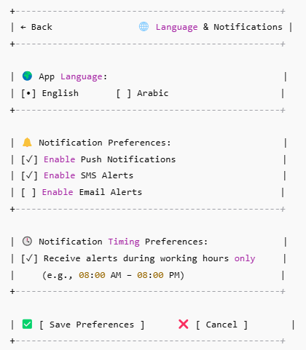

Screen Behavior
- App Language is a single-select toggle between English and Arabic.
- Notification types (Push, SMS, Email) can be enabled/disabled independently.
- Timing toggle applies only if at least one alert type is enabled.
- Changes are saved instantly upon clicking Save Preferences.
- If no channel is selected, system may prompt the user to select at least one.

Attributes Description
Field Name | Description | Type | Validation
App Language | Preferred language of the app | Radio | Required
Push Notifications | Toggle push notifications | Checkbox | Optional
SMS Alerts | Toggle SMS notifications | Checkbox | Optional
Email Alerts | Toggle email alerts | Checkbox | Optional
Notification Time Restrict | Restrict alerts to working hours (e.g. 8 AM to 8 PM) | Checkbox | Applies only if alerts are enabled

Messages and Validations
Scenario | Message/Validation
No notification method selected | "Please select at least one alert method."
Successful save | "Preferences updated successfully."
Language switch to Arabic | App reloads UI in Arabic immediately
Invalid time range (if editable in future) | "Please select a valid time range." (if applicable)

Security and Permissions
Action | Required Permission | Roles
View Settings | VIEW_SETTINGS | Caregiver
Modify Settings | MODIFY_NOTIFICATION_PREF | Caregiver

Backend API Requirements
Endpoint | Method | Description | Request Payload | Response
/api/settings/notifications | GET | Get current settings | — | {language, push, sms, email, restrictTime}
/api/settings/notifications | POST | Update settings | {language, push, sms, email, restrictTime} | {success: true}

Audit Trail
Event | Captured Fields
Language Updated | user_id, old_language, new_language, timestamp
Notification Changed | user_id, type (Push/SMS/Email), status, time

Error Handling and Edge Cases
Scenario | System Behaviour
Server error during save | Show toast: "Failed to update preferences. Please try again."
No internet connection | Show offline banner and prevent save action
Incomplete payload from backend | Load defaults (English, all alerts enabled) and notify user silently
Backend returns invalid enum for language | Fall back to English, notify silently

Settings – Profile & Contact Info

Description
This screen allows caregivers to view and update their profile details such as name, mobile number, and email address. The CPR number is shown as a read-only field for reference. These details are used for system alerts, messaging, and escalation workflows.

Instantiation of the Event
- Trigger: User taps “Profile & Contact Info” from the App Settings menu.
- Entry Points: Settings → Profile & Contact Info
- Pre-conditions:
  - User is logged in as a caregiver.
  - Profile information exists in the system.
- Post-conditions:
  - Updated contact details are saved.
  - Changes reflect in escalation/emergency contact workflows.

User Interface Design

Screen Layout
UI Component | Description
Name | Editable text field to input full name
Mobile Number | Editable text field for mobile phone number (SMS alerts)
Email Address | Editable field for email (used in escalation/notifications)
CPR Number | Display-only CPR field for identification
Last Updated Info | Read-only timestamp of the last update
Save / Cancel | Buttons to submit or discard changes
Info Note | Instructional message about system usage of contact info

Wireframe
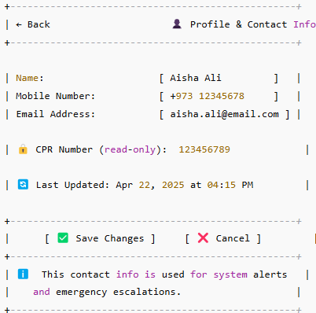

Screen Behavior
All fields are editable except CPR number.
Save button is enabled only if changes are detected.
On successful save, confirmation message is shown.
CPR is masked/read-only to prevent editing.

Attributes Description
Field Name | Description | Type | Validation
Name | Caregiver full name | Text | Mandatory, min 2 chars
Mobile Number | SMS/contact number | Numeric | Mandatory, 8–15 digits, Bahrain format
Email Address | Email for system notifications | Email | Optional, if entered must be valid
CPR Number | National ID (read-only) | Text | None (display only)
Last Updated | Timestamp of last profile update | Text | Auto-generated

Messages and Validations
Scenario | Message/Validation
Name is empty | “Please enter your name.”
Mobile number is invalid | “Enter a valid mobile number (e.g., +973…).”
Email format is invalid | “Please provide a valid email address.”
Successful update | “Profile updated successfully.”
No changes detected | “No updates to save.”

Security and Permissions
Action | Required Permission | Roles
View profile | view_profile_info | Caregiver
Edit profile | edit_profile_info | Caregiver

Backend API Requirements
Endpoint | Method | Description | Request Payload | Response
/api/caregiver/profile | GET | Fetch caregiver profile | N/A | {name, phone, email, cpr}
/api/caregiver/profile | PUT | Update profile details | {name, phone, email} | {status: success, updatedAt}

Audit Trail
Event | Captured Fields
Profile Updated | Name, Phone, Email, Timestamp, UserID

Error Handling and Edge Cases
Scenario | System Behaviour
API fails due to connectivity | “Unable to connect. Please try again later.”
Email already used in another account | “This email is already associated with another caregiver.”
Session expired | Redirect to login screen

Settings – Security Settings

Description
This screen allows caregivers to manage the security of their app usage. They can update their password or PIN, enable biometric authentication for ease of access, and manage device sessions by logging out from other devices remotely.

Instantiation of the Event
- Trigger: User selects Security Settings from the Settings menu.
- Entry Points: Accessible via main menu → Settings → Security Settings.
- Pre-conditions:
  - User is logged into the caregiver app.
  - Proper authentication completed.
- Post-conditions:
  - Security preferences (PIN/password/biometric) are updated.
  - Remote sessions can be terminated successfully.

User Interface Design

Screen Layout
UI Component | Description
Change Password Button | Opens modal to update current password
Change PIN Button | Opens modal to change PIN
Biometric Login Toggles | Switch to enable/disable fingerprint or Face ID login
Active Device List | Shows list of devices with active sessions
Logout Other Devices | Button to logout from all except current device
Save Settings | Confirms and saves changes
Cancel | Discards changes made on this screen

Wireframe
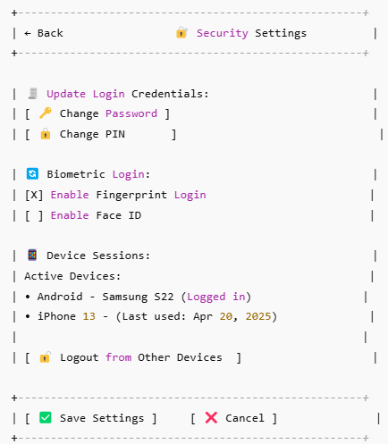

Screen Behavior
- User must enter current password/PIN before creating new ones.
- Fingerprint/FaceID toggle only available on supported devices.
- Device sessions list fetched in real-time via backend.
- Cannot remove active session from current device.
- "Save" button disabled unless at least one field is changed.

Attributes Description
Field Name | Description | Type | Validation
currentPassword | Current app login password | Text | Required, min 6 chars
newPassword | New password to update | Text | Required, min 8 chars, must differ from current
currentPIN | Current login PIN | Numeric | Required, exactly 4 digits
newPIN | New login PIN | Numeric | Required, exactly 4 digits, not same as old PIN
biometricEnabled | Biometric login toggle | Boolean | Device support check, FaceID or fingerprint required
activeDevices[] | List of active devices with metadata | Object[] | Non-editable list

Messages and Validations
Scenario | Message/Validation
New password is same as current | "New password must be different from current password."
PIN not 4 digits | "PIN must be exactly 4 digits."
Device doesn't support biometrics | "Biometric authentication not supported on this device."
Logout all triggered | "All other sessions will be logged out."

Security and Permissions
Action | Required Permission | Roles
Change password/PIN | Update Security Settings | Caregiver
Enable biometric login | Configure Biometric Auth | Caregiver
View active devices | Read Device Sessions | Caregiver
Logout from other devices | Manage Device Sessions | Caregiver

Backend API Requirements
Endpoint | Method | Description | Request Payload | Response
/api/security/update-password | POST | Change caregiver's login password | { currentPwd, newPwd } | { success, message }
/api/security/update-pin | POST | Change login PIN | { currentPIN, newPIN } | { success, message }
/api/security/biometric | PUT | Enable/disable biometric login | { enabled: true/false } | { success }
/api/devices/list | GET | Get active login sessions | – | { devices: [...] }
/api/devices/logout-others | POST | Logout from all other devices | – | { success, loggedOutCount }

Audit Trail
Event | Captured Fields
Password Updated | userId, timestamp, IP address
PIN Updated | userId, timestamp, deviceId
Biometric Setting Changed | userId, biometricStatus, timestamp
Other Devices Logged Out | userId, loggedOutDevices[], timestamp

Error Handling and Edge Cases
Scenario | System Behaviour
Incorrect current password/PIN | Show error and block update
API timeout during device list retrieval | Show retry option with "Unable to load sessions"
Device does not support biometrics | Disable toggle and show info message
Attempt to logout current session | Disable selection, mark as active device with lock icon

Settings – App Info & Help

Description
This screen provides caregivers with access to essential app-related information such as version number, legal documents, help resources, and NHRA compliance. It also includes contact details for technical or operational support.

Instantiation of the Event
- Trigger: Tapped from Settings > App Info & Help
- Entry Points: Main menu or footer in the caregiver app
- Pre-conditions:
  - Caregiver is logged into the app
  - Internet connectivity available (for viewing support docs or sending emails)
- Post-conditions:
  - View-only access to all documents and contact channels
  - No data modification allowed from this screen

User Interface Design

Screen Layout
UI Component | Description
App Version | Shows app version and build number
Terms of Use Button | Opens static terms of use page
Privacy Policy Button | Opens privacy policy document
View FAQs Button | Redirects to in-app FAQ viewer or embedded help article
Contact Support Panel | Displays phone, email, and response details
NHRA Compliance Statement | Opens regulatory compliance message/page

Wireframe
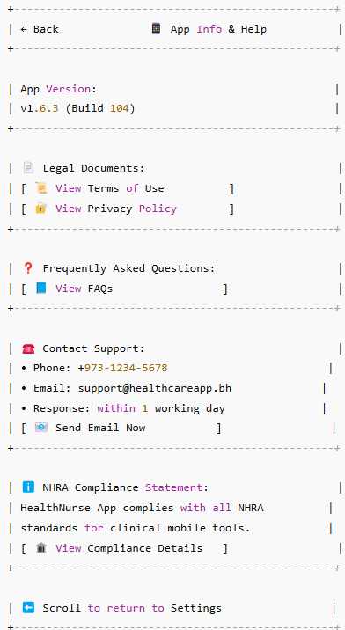

Screen Behavior
- App version is auto-fetched from system metadata.
- All buttons redirect to view-only screens (PDF viewer or in-app browser).
- Email button opens the user’s email client pre-filled with support address.
- NHRA compliance section is static and non-editable.

Attributes Description
Field Name | Description | Type | Validation
App Version | Version and build code | String | System-fetched
View Terms of Use | Button to open legal terms document | Button | Always enabled
View Privacy Policy | Button to open privacy statement | Button | Always enabled
View FAQs | Help and usage guidance | Button | Always enabled
Support Phone | Contact number for app-related support | String | Valid local format (+973)
Support Email | Support email address | Email | Valid format, clickable
Compliance Details | NHRA compliance reference info | Button | Opens static screen

Messages and Validations
Scenario | Message/Validation
No internet while opening legal doc | “Please connect to the internet to view this document.”
Invalid email launch | “Could not launch email client.”
Compliance details load failure | “Unable to load compliance statement.”

Security and Permissions
Action | Required Permission | Roles
View App Info | View only | Caregiver
Open Documents | Read access | Caregiver
Contact Support | No special permissions | Caregiver

Backend API Requirements
Endpoint | Method | Description | Request Payload | Response
/app/version | GET | Fetch app version and build | None | {version: "1.6.3", build: "104"}
/docs/terms | GET | Retrieve terms of use content | None | PDF or HTML blob
/docs/privacy | GET | Retrieve privacy policy content | None | PDF or HTML blob
/docs/faqs | GET | Load FAQ content | None | Structured help content
/compliance/nrha | GET | View NHRA compliance statement | None | Static text or markdown

Audit Trail
Event | Captured Fields
Viewed App Info | User ID, Timestamp
Viewed Terms | User ID, Timestamp, Document Type
Opened Email | User ID, Timestamp, Support Email Trigger

Error Handling and Edge Cases
Scenario | System Behaviour
API failure while loading documents | Show cached version if available or fallback message
Device email client unavailable | Disable ‘Send Email’ button and show guidance
NHRA compliance info not configured | Show message: “Details not available. Contact admin.”

Settings – Caregiver Preferences

Description
This screen allows caregivers to personalize their in-app experience by selecting default views (like list or grid for visit lists), time format preference, and frequency of automatic sync with the server. These settings are stored on a per-device basis.

Instantiation of the Event
- Trigger: Tap on Caregiver Preferences under the Settings menu.
- Entry Points: From Settings screen.
- Pre-conditions:
  - User is authenticated as a caregiver.
  - Device has local storage access.
- Post-conditions:
  - Updated preferences are stored and applied to the device.
  - Preference sync is queued for offline mode if offline.

User Interface Design

Screen Layout
UI Component | Description
Default View | Select between list or grid for visit listings
Time Format | Choose between 24-hour or 12-hour (AM/PM) clock
Auto-Sync Frequency | Dropdown to select how often the app syncs in background
Save Preferences Button | Saves the current configuration
Cancel Button | Discards changes and returns to previous screen
Informational Note | Clarifies that settings apply only to current device

Wireframe
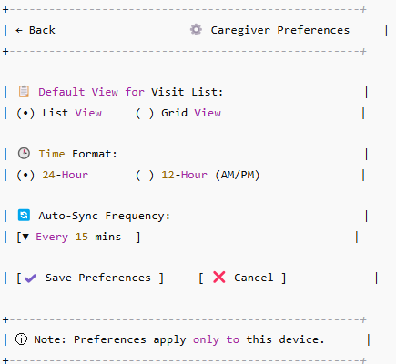

Screen Behavior
- Default View
  - Toggle between two mutually exclusive radio options (List or Grid).
  - Saves view type for visit list pages.
- Time Format
  - Two radio options (24-hour or 12-hour). Used in timestamps for visits, logs, etc.
- Auto-Sync Frequency
  - Drop-down with values like: Every 5 mins, 15 mins, 30 mins, Manual only.
  - Validation ensures a value is selected before saving.
- Save Preferences
  - Commits values to local storage and sends to backend for sync.
- Cancel
  - Navigates back without saving changes.

Attributes Description
Field Name | Description | Type | Validation
defaultView | List or grid view option | Enum | Required
timeFormat | 24-hour or 12-hour clock format | Enum | Required
autoSyncFrequency | Frequency of background sync | Enum | Required, must be valid enum

Messages and Validations
Scenario | Message/Validation
No auto-sync frequency selected | “Please select a sync frequency.”
Save successful | “Preferences updated successfully.”
Backend error | “Could not save preferences. Try again later.”

Security and Permissions
Action | Required Permission | Roles
View Preferences | App Access | Caregiver
Update Preferences | Modify Settings (Local only) | Caregiver

Backend API Requirements
Endpoint | Method | Description | Request Payload | Response
/api/preferences/update | POST | Save caregiver preferences | { defaultView, timeFormat, autoSyncFrequency } | { success: true/false, message }

Audit Trail
Event | Captured Fields
Preferences Updated | defaultView, timeFormat, autoSyncFrequency, timestamp, deviceId

Error Handling and Edge Cases
Scenario | System Behaviour
Device offline | Store locally and sync when back online
API fails to save | Show error message and allow retry
Invalid enum in request | Prevent save, re-render current screen with warning
Caregiver exits without saving | Discard changes, retain previous saved settings

APPENDICES

Data Model

Core Collections Design
Collection Name | Purpose | Key Fields
users | Stores caregiver login profiles & roles | user_id, name, role, license_number, assigned_facility, permissions, device_info
patients | Patient master record for assigned cases | patient_id, cpr_id, name, age, gender, address, allergies[], chronic_conditions[], current_medications[], assigned_caregivers[]
visits | Daily visit assignments with caregiver-task linkage | visit_id, patient_id, caregiver_id, scheduled_time, status (pending/in-progress/completed), location, start_time, end_time, remarks
visit_tasks | Checklist items linked to a visit | task_id, visit_id, description, completed (boolean), completed_at
vitals | All vitals captured manually or via device | vital_id, visit_id, patient_id, caregiver_id, entry_mode, temperature, bp_systolic, pulse, measured_at, source
notes | Clinical notes added by caregiver | note_id, visit_id, patient_id, caregiver_id, note_type, note_text, timestamp, media_url
uploads | Media files uploaded during a visit | file_id, visit_id, patient_id, caregiver_id, document_type, file_url, timestamp, description
evv_logs | GPS/NFC/OTP logs for check-in/check-out | evv_id, visit_id, caregiver_id, method, gps_coordinates, otp_code, check_in_time, check_out_time, remarks
escalations | Emergency escalations logged by caregivers | escalation_id, visit_id, patient_id, caregiver_id, reason, vitals_snapshot, remarks, attachment_url, notification_methods[], timestamp
sync_queue | For offline sync tracking | sync_id, caregiver_id, action_type, payload_snapshot, timestamp, retry_count, status (pending/success/failed)
notifications | Alerts and messages received by caregiver | notification_id, user_id, title, body, type, linked_screen, is_read, created_at
chat_threads | Chat between caregiver and supervisors/doctors | thread_id, visit_id, participants[], messages[] (each with sender_id, message_text, timestamp, attachment_url)

Data Relationships (Reference Model)
- visit_id is the central link across visit_tasks, vitals, notes, uploads, evv_logs, escalations
- caregiver_id links users, visits, notes, uploads, evv_logs, chat_threads
- patient_id links to patients, visits, vitals, uploads, notes, escalations

Recommended Indexing
- visits: compound index on {caregiver_id, scheduled_time}
- vitals: {visit_id}, {patient_id, measured_at}
- sync_queue: {caregiver_id, status}
- notifications: {user_id, is_read}

Permissions Layer (Suggested Roles)
- Caregiver: CRUD on visits, vitals, notes, uploads, escalations
- Nurse Supervisor: Read-only on all caregiver logs, approve escalations
- Backend Service: System role for syncing, offline recovery, audit logging

ERD

Diagram
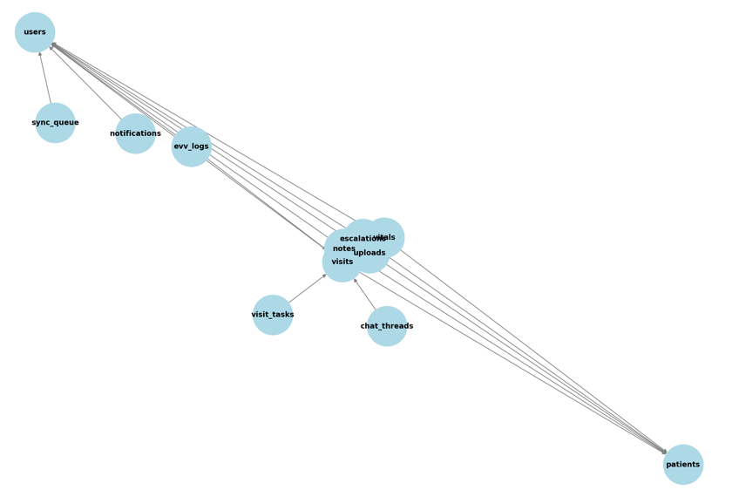

Highlights
- Central hub: visits collection — linked to patients, caregivers, and all visit-related logs.
- Each function (notes, vitals, uploads, EVV, escalations) is modular and linked to both visit_id and patient_id.
- users acts as a parent reference for caregivers and notification targets.
- chat_threads and sync_queue manage communication and offline behavior.

Sync Visit Vs Offline Sync Status

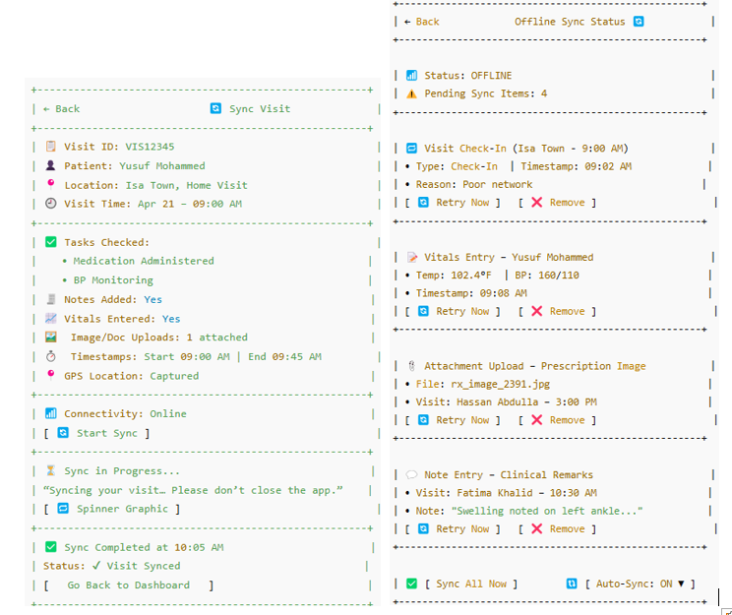

Sync Visit (Visit-Level Sync Screen)

Purpose:
To manually sync a completed visit (all tasks done, notes filled, vitals entered, etc.).

Context:
- Triggered per visit after all documentation is complete.
- Caregiver initiates the sync for that specific visit.
- Shows a detailed summary specific to one visit only.

Features:
- Shows status of all relevant visit data.
- Performs one-time sync of that visit's data.
- Confirmation once sync is successful.

Offline Sync Status (Global Sync Queue)

Purpose:
To monitor and retry syncing for all offline items when device was disconnected or sync failed earlier.

Context:
- Triggered from the Sync Queue tile on landing screen.
- Displays a list of all failed sync items (not just full visits).
- Useful when device goes offline and user wants to sync in bulk or individually retry items.

Features:
- Works across multiple visits, patients, file types (check-ins, vitals, notes, attachments).
- Retry or delete each item.
- Bulk sync with "Sync All Now".
- Toggle auto-sync on/off when back online.

Key Difference:
Criteria | Sync Visit (Left) | Offline Sync Status (Right)
Scope | Single visit only | All failed/queued items
Entry Point | After completing a visit | From Sync Queue menu
Sync Action | Manual sync by visit | Retry individual or all offline syncs
Ideal Usage | Real-time sync per visit | Offline recovery / bulk syncing
Data Types Supported | Full visit data | Check-in, vitals, notes, uploads etc.

